**RTI Comment Handling and Response Manager (RTI CHARM®) User’s Guide**

**Part 1: Users**

RTI International

3040 Cornwallis Road

P.O. Box 12194

Research Triangle Park, NC 27709-2194

September 2022

Version 4.0



Forward

This document was developed by RTI International to provide useful information to users of the RTI Comment Handling and Response Manager (RTI CHARM®) tool. The RTI CHARM tool was developed internally by RTI International for use by RTI and its contracted partners in processing public comments.

There are two parts to this document, *RTI Comment Handling and Response Manager (RTI CHARM) User’s Guide:*

Part 1: Users

Part 2: RTI Project Managers and Administrators

Part 1 is intended to aid comment excerpters, summarizers, responders, as well as comment and RTC reviewers. Part 1 may be distributed to external partners and clients who are approved to use the RTI CHARM tool.

Part 2 has been developed to document additional project planning and administrative processes related to the RTI CHARM tool beyond general user needs. Part 2 is intended for use by RTI staff only and is not for distribution outside of RTI.

**Part 1 Contents**

[Purpose of the RTI CHARM Tool 5](#_Toc115440142)

[Overview of Comment Screening and Processing 6](#_Toc115440143)

[Terminology and User Roles 7](#_Toc115440144)

[RTI CHARM Tool Account Registration and Login 8](#_Toc115440145)

[RTI CHARM Tool Internet Address 8](#_Toc115440146)

[Registering for an RTI CHARM Tool Account 8](#_Toc115440147)

[Logging In 9](#_Toc115440148)

[Recommended Internet Browser 9](#_Toc115440149)

[Session Time Out 9](#_Toc115440150)

[Projects Tab 11](#_Toc115440151)

[Project Information Tab 12](#_Toc115440152)

[Project Documents Tab 13](#_Toc115440153)

[Project Dashboard Tab 14](#_Toc115440154)

[Navigating the Outline, Comments, Excerpts, Summaries/Responses, Generate RTC, Search, and Help Tabs 15](#_Toc115440155)

[Scroll Bars and Page Advancement 16](#_Toc115440156)

[Sorting and Filtering in Tables 16](#_Toc115440157)

[Outline Tab 20](#_Toc115440158)

[Adding or Editing an Outline Section 21](#_Toc115440159)

[Deleting an Outline Section 22](#_Toc115440160)

[Temporary Outline Sections 22](#_Toc115440161)

[Outline Printout 23](#_Toc115440162)

[Comments Tab 24](#_Toc115440163)

[View a Comment 26](#_Toc115440164)

[Adding Comments to the RTI CHARM Tool 27](#_Toc115440165)

[Editing Comment Information 28](#_Toc115440166)

[Deleting a Comment 28](#_Toc115440167)

[Updating the Comment Status Fields 28](#_Toc115440168)

[Entering Excerpts 28](#_Toc115440169)

[Duplicating Excerpt 30](#_Toc115440170)

[Excerpts Tab 33](#_Toc115440171)

[Summaries/Responses Tab 35](#_Toc115440172)

[Summary/Response Sort Order 38](#_Toc115440173)

[Selection of Excerpts When Building Summaries 39](#_Toc115440174)

[Drafting Responses 39](#_Toc115440175)

[Updating the Status when Summary or Response Work is Complete 39](#_Toc115440176)

[Splitting an Excerpt, Summary or Response 40](#_Toc115440177)

[Moving Excerpts, Summaries and Responses 40](#_Toc115440178)

[Generate Response to Comments (RTC) Tab 42](#_Toc115440179)

[Formatting the RTC Document 46](#_Toc115440180)

[Using the RTI CHARM Tool Text Boxes 48](#_Toc115440181)

[RTI CHARM Tool Text Box Formatting Bar for Excerpts, Summaries, and Responses 48](#_Toc115440182)

[Tables, Figures, and Equations 49](#_Toc115440183)

[Footnotes 49](#_Toc115440184)

[New Data 50](#_Toc115440185)

[Discussion of Rule Text Changes 50](#_Toc115440186)

[Spell Check 50](#_Toc115440187)

[Working with pdfs (Tips for Excerpters) 50](#_Toc115440188)

[Inclusion of Surrounding Text in Excerpts for Context 54](#_Toc115440189)

[Search Tab 55](#_Toc115440190)

[Manage Users Tab [only for administrative role] 57](#_Toc115440191)

[Unlock Summaries Tab [only for administrative role] 59](#_Toc115440192)

[Comments Imports Tab [only for administrative role] 60](#_Toc115440193)

[Help Tab 61](#_Toc115440194)

# Purpose of the RTI CHARM Tool

RTI designed the RTI Comment Handling and Response Manager (RTI CHARM) tool to improve the efficiency of public comment processing projects by:

* Providing password-protected web-based access to approved project team members and reviewers located anywhere,
* Eliminating the need to compile Word documents from multiple users and reviewers,
* Characterizing comments,
* Allowing for section-by-section response-to-comments (RTC) document generation (real-time access to most recent version),
* Linking comment excerpts or summary text back to each comment letter, and
* Providing quick access to each comment letter.
* Allowing users to search for key words or key phrases of interest within excerpted and summarized text.

The RTI CHARM tool was designed for projects with large numbers of public comments that require rapid processing but is equally useful for smaller comment processing tasks. Essentially, any comment-processing task that involves multiple writers and reviewers working together to complete an RTC document is ideally suited for the RTI CHARM tool.

The RTI CHARM tool is designed to generate response-to-comment (RTC) documents including either an:

* Excerpts and responses, or
* Comment summaries and responses

# Overview of Comment Screening and Processing

RTI’s methodology for public comment screening and processing is shown in Figure 1.

Comment Screening

RTICHARM Tool Processing

Figure 1. Overview of Comment Processing

# Terminology and User Roles

Common terms used in this document are as follows:

|  |  |
| --- | --- |
| **Terms** | **Description** |
| Comment, comment letter, or comment attachment | Each public comment file (e.g., comment email, letter, or attachments) with a unique docket identification number downloaded from the docket at *Regulations.gov.* |
| Excerpt | A selection of text cut and paste verbatim from a comment. |
| Summary | A summary of one or more excerpts from public comments. A summary may consolidate multiple related comments, consolidate repetitive details submitted by commenters, and change the tense of comments to include phrases like “the commenter stated...” or “several commenters disagreed with....” |
| Response | A response to each comment summary drafted and/or reviewed by the client. |
| Response to comments or  RTC document | The comment-response document developed from excerpting and/or summarizing and responding to public comments. RTC documents may be either:   * excerpt-response documents (omitting the need to summarize comment and simply responding directly to excerpted text/comments), or * summary-response documents (consolidating excerpts into summaries prior to response development). |
| Outline | The outline included in the RTI CHARM tool which becomes the outline of the response to comments document. |

User roles referred to in this document are as follows:

|  |  |
| --- | --- |
| **User Role** | **Description** |
| Excerpter | A project team member who cuts excerpts from comments, pastes them into the RTI CHARM tool, and assigns them to the proper RTC outline section. |
| Summarizer | A project team member familiar with the comment subject matter who consolidates excerpts entered into the RTI CHARM tool into comment summaries. |
| Responder | A project team member who drafts responses to comment summaries (or excerpts in the case of excerpt-response RTC documents). |
| Reviewer | A project team member who reviews excerpts, summaries, and/or responses at various stages prior to publication of the final RTC document. |
| Administrative | Administrative roles are specific to RTI staff and include the RTI CHARM tool Coordinator, Project Manager, and Site Administrator. |

# RTI CHARM Tool Account Registration and Login

## RTI CHARM Tool Internet Address

<https://rti-charm.rti.org/>

## Registering for an RTI CHARM Tool Account

The RTI CHARM tool is a password-protected system available online for registered and approved users to access from anywhere. Users are invited to register for the RTI CHARM tool based on project-specific needs as identified by the client funding the project and/or RTI’s project manager. Registration and project-specific access permissions are limited to pre-approved users to protect the security and integrity of deliberative comment responses. Once approved to register for the RTI CHARM tool, you will be assigned a user role (e.g., excerpter, summarizer/responder) for each project you have been granted access to view. Permissions for registered users in the RTI CHARM tool may be restricted based on your user role at the discretion of the client funding the project and/or RTI’s project manager.

Navigate to the Internet address above. Register for the RTI CHARM tool at the log in page shown below.

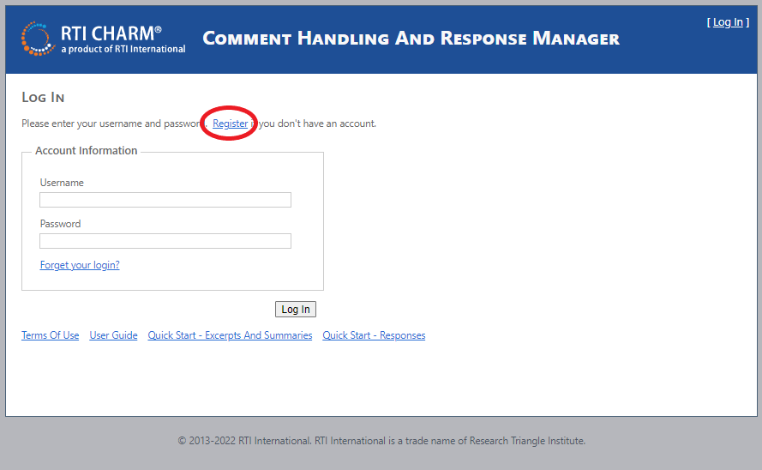

The registration form will ask you to provide the following account information:

|  |  |
| --- | --- |
| **Account Information** | **Description** |
| Username | Create the username you wish to use to log into the RTI CHARM tool for each work session |
| First name | Your first name |
| Last name | Your last name |
| Affiliation | Your company (e.g., RTI, EPA, FDA) |
| Phone | Work phone |
| Email | Work email |
| Password | The password you wish to use each time you log into the RTI CHARM tool |
| Confirm password |  |

Click on Create User

You will receive an email from RTI once you have been approved to log into the RTI CHARM tool. Approval of your registration request may take 1-2 days. However, if you have an immediate need, please notify the RTI CHARM Tool Coordinator (Lisa Scruggs, (919) 316-3745, [lkscruggs@rti.org](mailto:lkscruggs@rti.org)).

## Logging In

After you have been notified of approval to access the RTI CHARM tool, use your registered username and password to log in to the RTI CHARM tool (<https://rti-charm.rti.org/>).

## Recommended Internet Browser

Although different browsers (e.g., Microsoft Edge, Google Chrome, Firefox) can be used, the RTI CHARM tool has been designed for and tested more thoroughly in Internet Explorer. Therefore, we recommend using a recent version of Internet Explorer.

## Session Time Out

The RTI CHARM tool is set to time out after 8 hours of inactivity. If the RTI CHARM tool times out during a session, simply log in again.

RTI CHARM Tool Tabs

There are 11 main tabs within the RTI CHARM tool that all users have access to. Use the tabs at the top of the page to navigate the RTI CHARM tool.

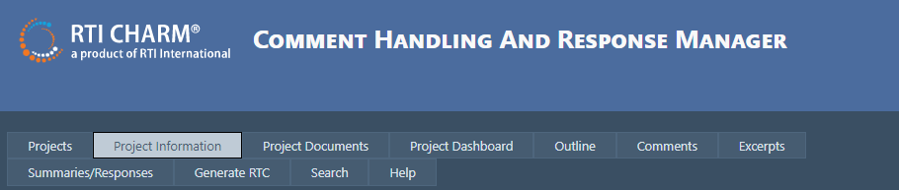

In addition, users with an Administrative role have access to three additional tabs:

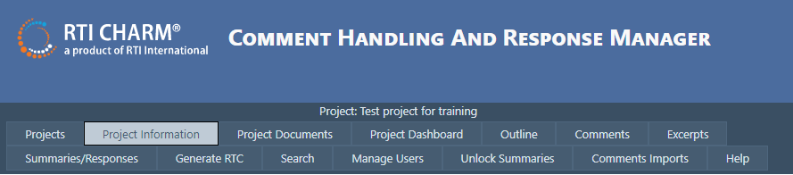

Individual tabs are described further in sections below.

# Projects Tab

Once logged in using your registered username and password, you will see a list of projects you are approved to work on. In order to be approved for a project, Project Administrators need to send a list of users they would like to add to their project to the RTI CHARM Tool Coordinator. The Coordinator will add approved users to the project and provide them access based on the preference of the Project Administrator (read only, excerpter, summarizer/responder).

Select the project you are ready to work on.

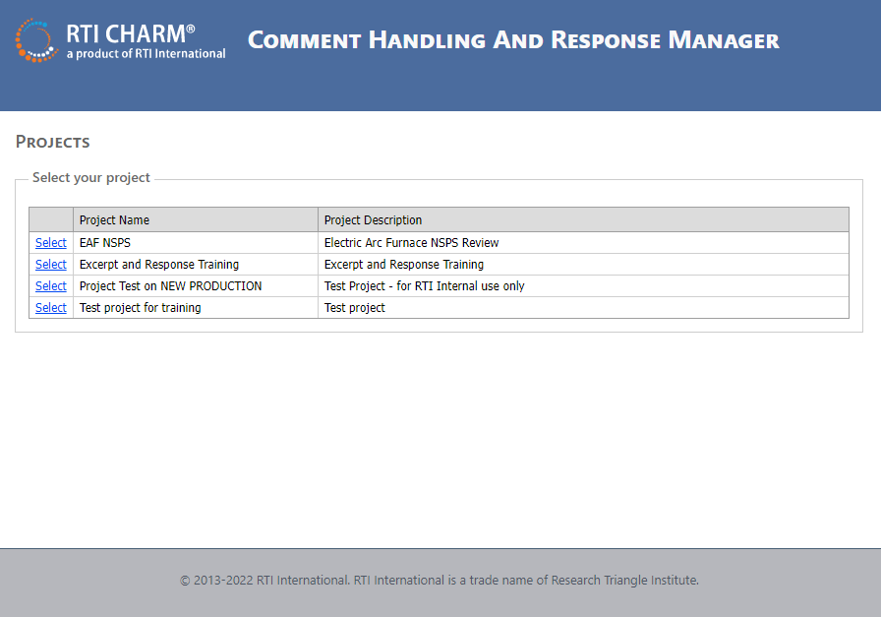

Most users will only be assigned to one project at a time. However, if you need to switch between projects, you must return to the Projects page and select a different project.

# Project Information Tab

Once you have logged in and selected a project, the first page you will see is the Project Information page. The RTI Project Manager or the RTI CHARM Tool Coordinator posts notes on this page of interest to project users.

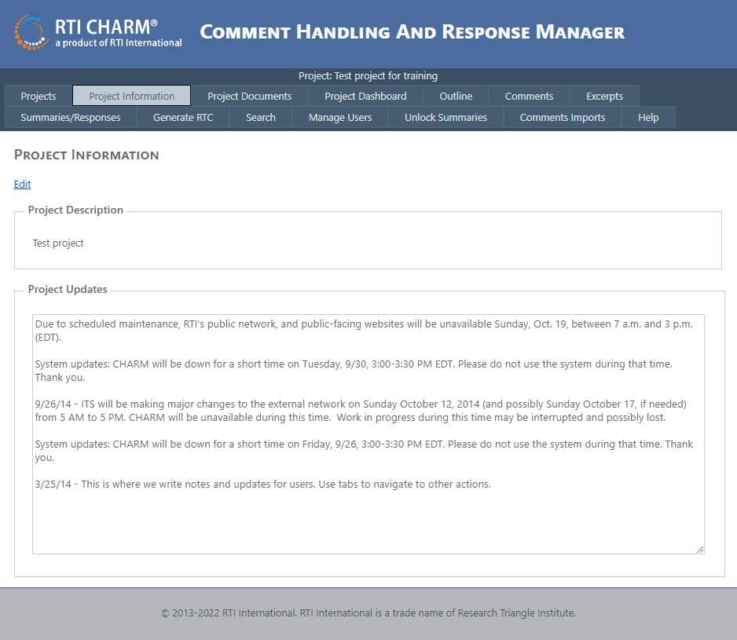

Project users do not have the option to post notes on this page directly, this is something only Project Administrators have access to edit. Please contact your Project Administrator(s) if you wish to post a note for the project team to see.

# Project Documents Tab

The RTI Project Manager or the RTI CHARM Tool Coordinator can post documents on this page of interest to the project. To open a file, click the View link.

Project users do not have the option to post documents on this page directly, this is something only Project Administrators have access to. Documents can be added by left clicking on the Add Project Document button.

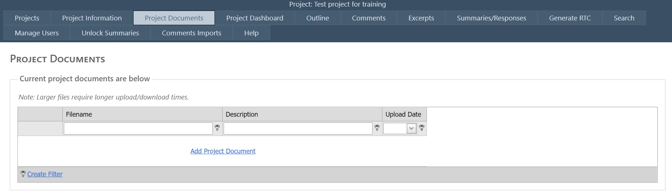

One Project Administrators have posted a document, they have the option to Add, Edit (the Description field), or Delete files.

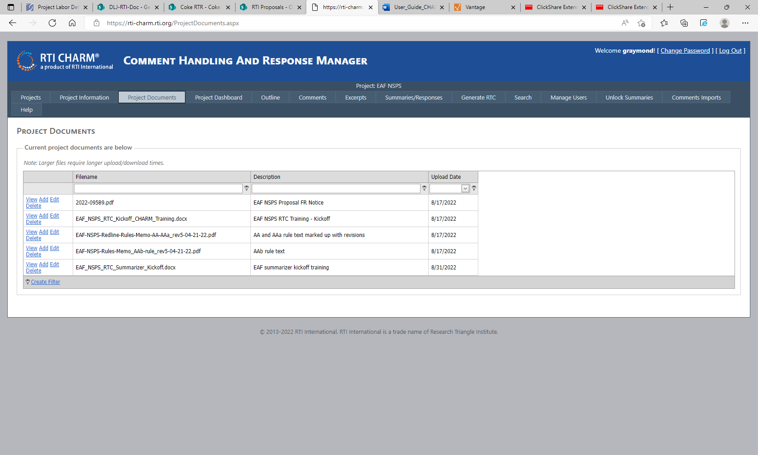

# Project Dashboard Tab

The Project Dashboard page contains graphs that Project Managers can use to track the excerpting and summarizing progress of the team. The first graph shows comments sorted by their status (i.e., New, In Process, Excerpted, Finished, Remove, and Total). The second graph shows the total number of Excerpts (summarized), Unsummarized excerpts, and Summaries/Responses. The Excerpts and Summaries/Responses graph can be modified to display counts by outline section if filtered on by outline section.

****

The outline section can be filtered by using the Section drop down menu.

# Navigating the Outline, Comments, Excerpts, Summaries/Responses, Generate RTC, Search, and Help Tabs

Use the tabs at the top of the page to navigate the RTI CHARM tool.

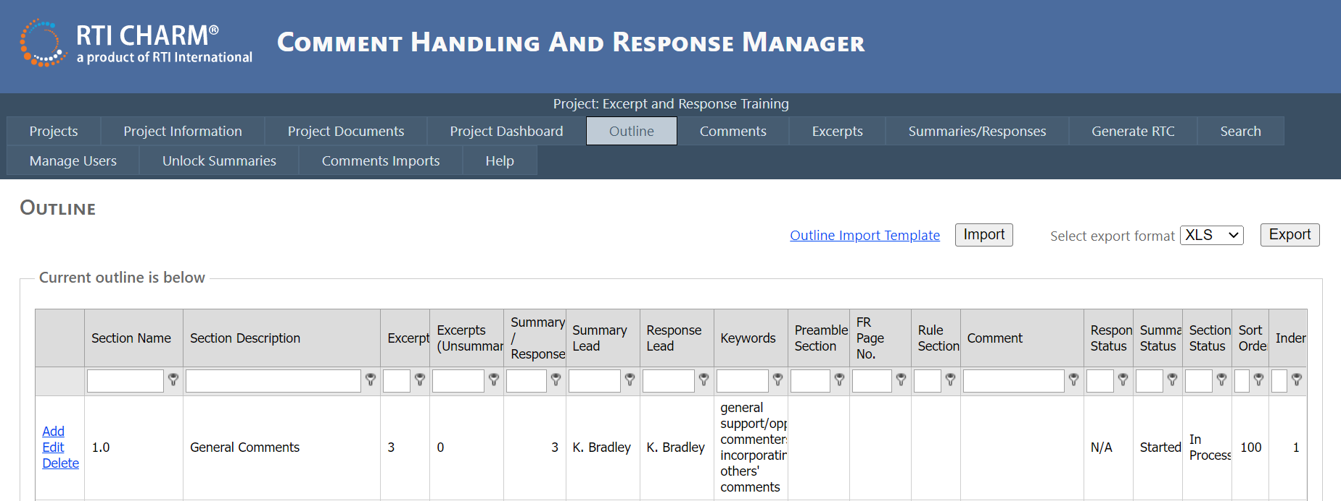

The Projects, Project Information, Project Document, and Project Dashboard tabs were discussed above. The other pages are:

|  |  |
| --- | --- |
| **Tab** | **Description** |
| Outline | Contains the comment document outline, assignments for summary and response, and fields for tracking excerpt, summary and response status by each outline section. |
| Comments | Contains comment letter information (affiliation and affiliation type) and excerpting assignments and status. Includes the starting point for entering excerpts from a selected comment. |
| Excerpts | Contains tracking and edit links for excerpts, sorted by section. |
| Summaries/Responses | Acts as the starting point for entering or editing a summary or response. Contains tracking for summary/response entries with add and edit links and is sorted by section. |
| Generate RTC | Provides options for generating a Word document containing excerpts or summaries with responses for selected outline sections. |
| Search | Provides options for keyword searches on excerpts, summaries, and/or responses. |
| Help | Contains the user guide and quick start guides. |

Note that the RTI CHARM tool administrators will also have a Manager Users, Unlock Summaries, Comments Imports tabs with functionality that is not available to general users.

## Scroll Bars and Page Advancement

Scroll bars appear at the right and on the bottom of the RTI CHARM tool Outline and Comments tabs. Use these scroll bars to navigate up and down, or side to side in the tables.

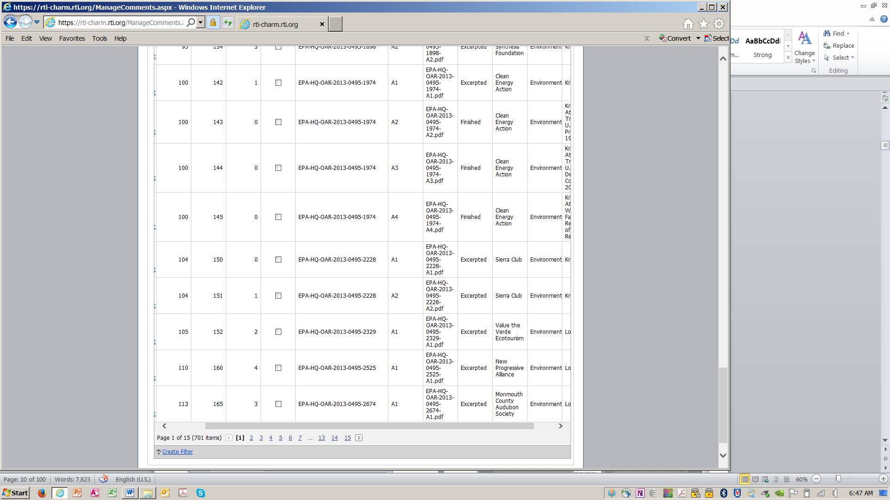

If tables are longer than a single page (one page will hold a maximum of 50 records), then page numbers are used to advance to different pages.

## Sorting and Filtering in Tables

The Project Documents, Outline, Comments, Excerpts and Summaries/Responses tabs all use tables as an entry point for actions, a status tracker, and a display of summarized information about each entry. All of these tables can be [sorted and filtered](onenote:How%20do%20I.one#Tables&section-id={CB895391-3ABB-44EB-9463-25A2D94577A7}&page-id={68772341-5C71-40D2-9AF4-7F870EAE9E09}&object-id={FCD50374-7872-47E3-BB22-0DC1ED61EB96}&2B&base-path=rtifile02\ehe\Projects\0271300.107-Comments_DB\Technical_Record\Documentation\CHARM%20Com), as illustrated below using the Comments tab as an example.

Column drag. If you would like to temporarily change the order of the columns, click on the name of a column and drag it to the right or the left. Note that the column ordering will revert back to its default setting after you leave the table.

Simple column sort. Left click on the heading of a column, and the table will sort by the items in that column. Left click again and it will reverse sort.

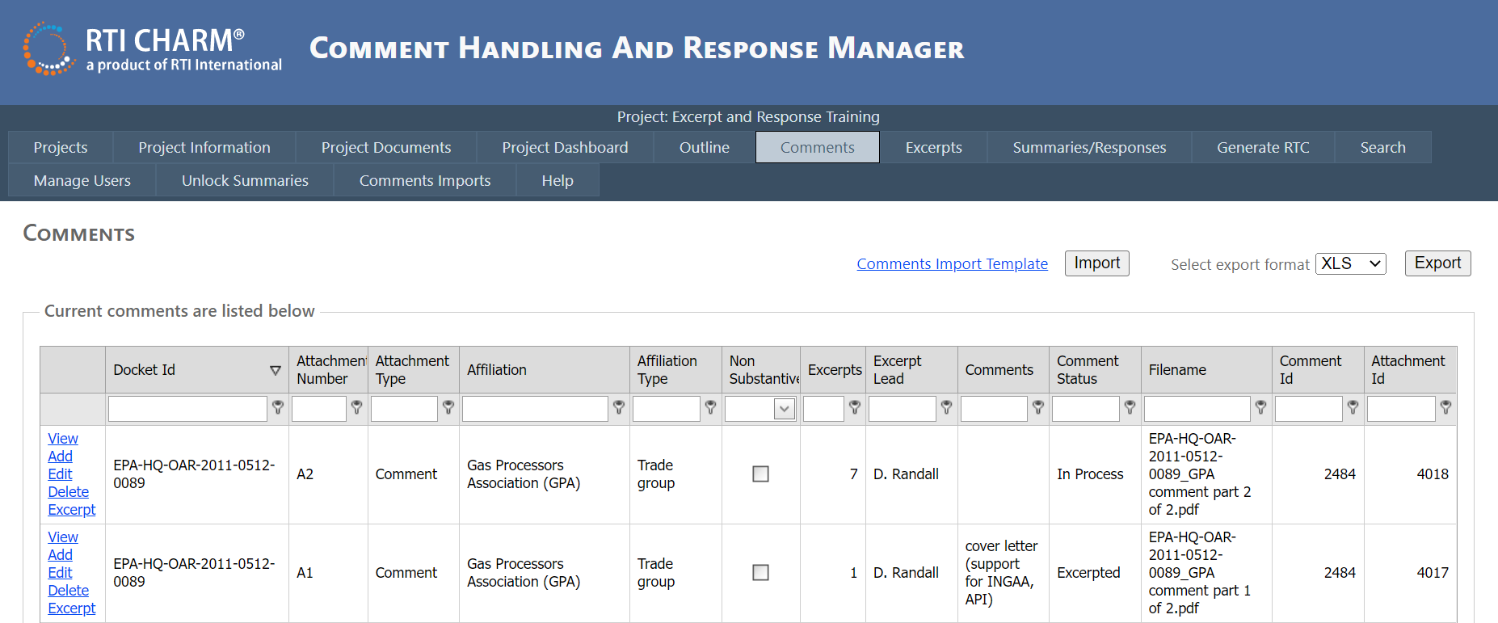

Basic column filter. The column filter function allows you to create a filter using a simple logical expression as shown below. The filter begins to work as you type in text. As a default, the filter is set to filter data that *Contains* the text that the user is entering into this field. If you would like to use a different filtering function, such as *Begins with* or *Equals*, select the key icon next to the short text box in the applicable column and select your filtering preference.

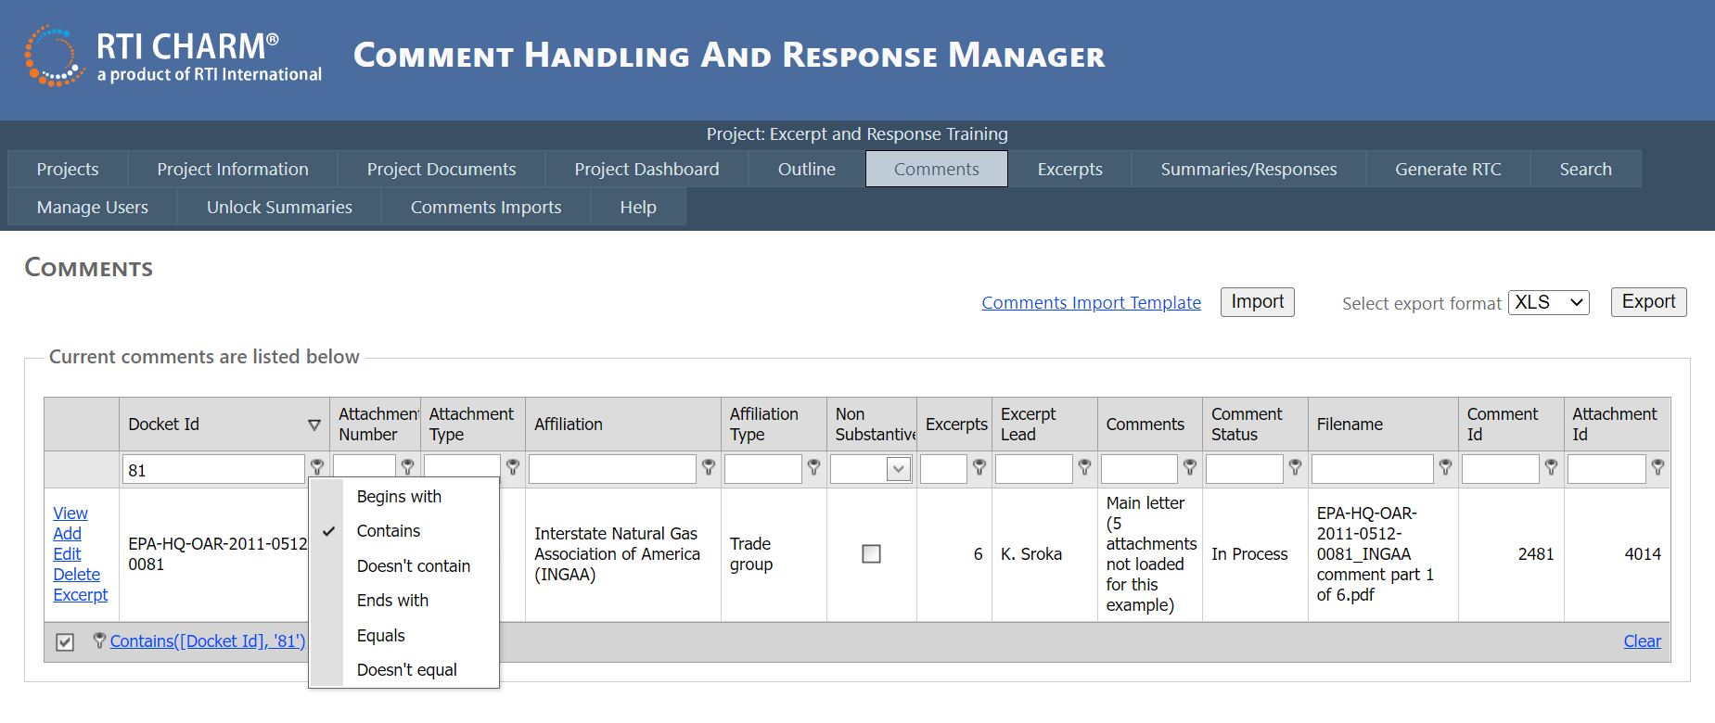

Once you apply a filter, the line at the bottom left of the table is a summary of the search terms presently in use as shown with the red arrow above.

Use the “Clear” option at the bottom of the page to un-filter the items.

A more complex filter can be built using the create filter option at the bottom of the page.

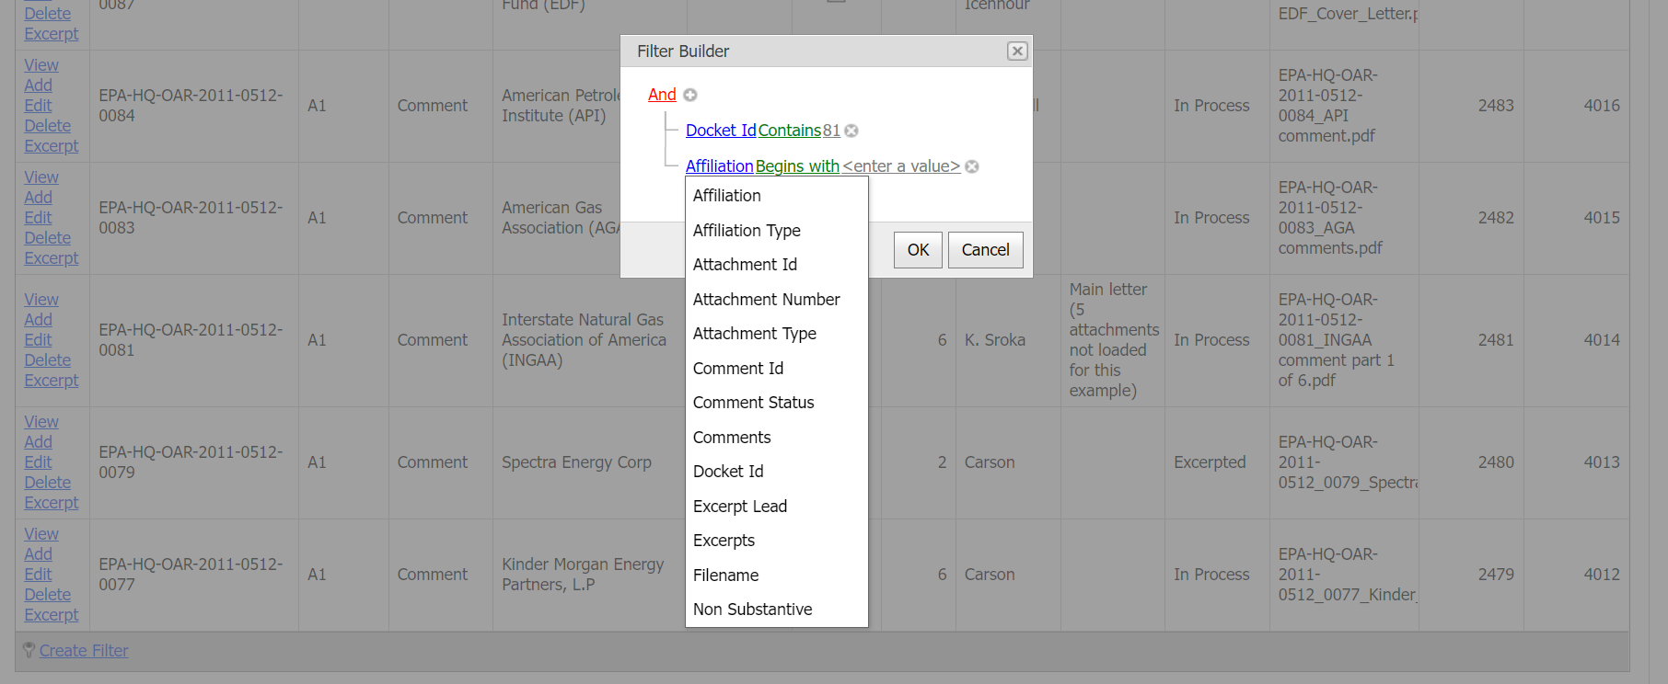

To add a line in the filter builder form, left click the plus symbol beside the word ‘And’. To remove a line, left click the X located next to the criteria you wish to omit. The first term in the line (blue text) is a column heading, selected from a drop-down list. The second is the operator (green text), also selected from a drop-down list. The third term (gray text) is the value, indicated by the user. The filter is not case sensitive and accepts partial words.

Uses for the sort and filter features:

In the Comments tab,

* Excerpters assigned specific comments can quickly identify their responsibilities.
* Administrators can track excerpt progress, sort comments by affiliation type, and assign comments.

In the Excerpts tab,

* Summarizers can use the internal notes field to characterize excerpts, then use the filter and sort features to group excerpts for summaries.
* Summarizers and Responders can track excerpt progress.

In the Summarizers/Responders tab,

* Summarizers and Responders can use the internal notes field to characterize summaries or responses, then use the filter and sort features to group summaries and responses.

An example comment table search is provided below.

*Example 1.* Suppose you want to find all the comments submitted by Industry. In the Comments tab, Affiliation type column, select the key. Ensure that the criteria is set to “Contains” and type in “Industry.” All of the Industry comments will filter out.

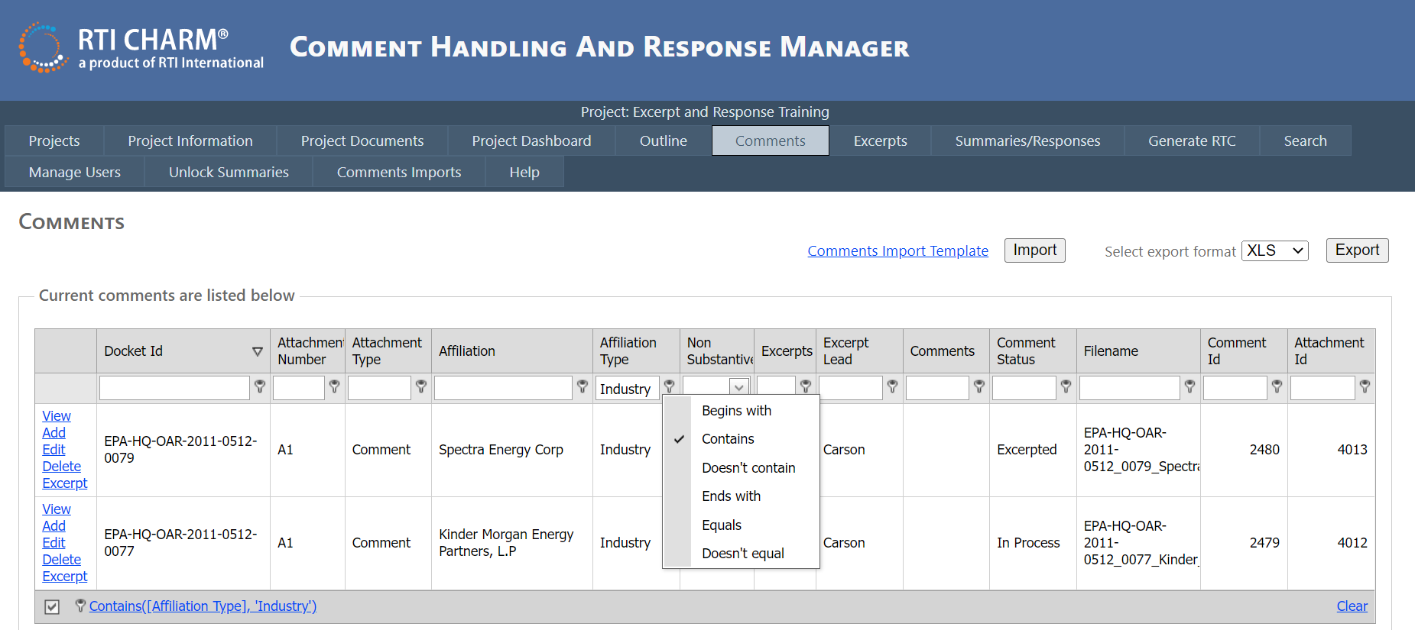

*Example 2.* Excerpter Tom wants to find the comment letters assigned to him that he hasn’t excerpted yet. He starts by looking at the Comment table. To identify the un-excerpted comments he is responsible for, he needs to filter two columns: the Excerpt Lead column on his name, and the Comment Status field on New.

To filter on two columns, Tom uses the Create Filter button at the bottom of the Comments screen to open the Filter Builder window. The Filter Builder has more options than the filters at the top of the columns.

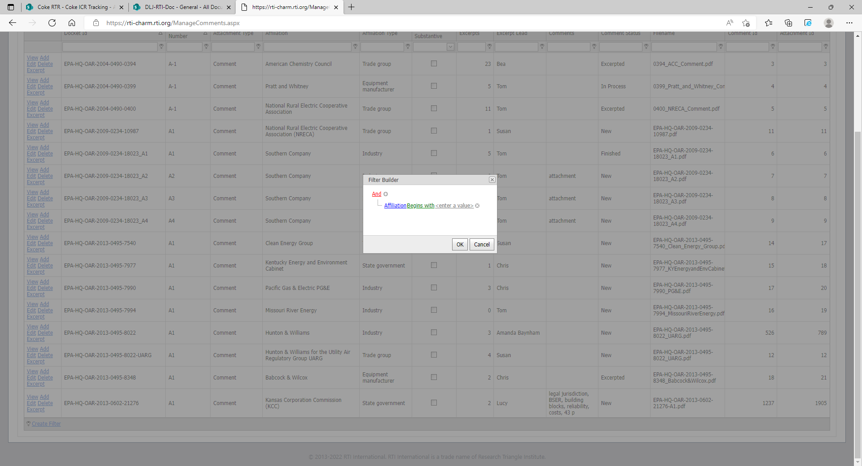

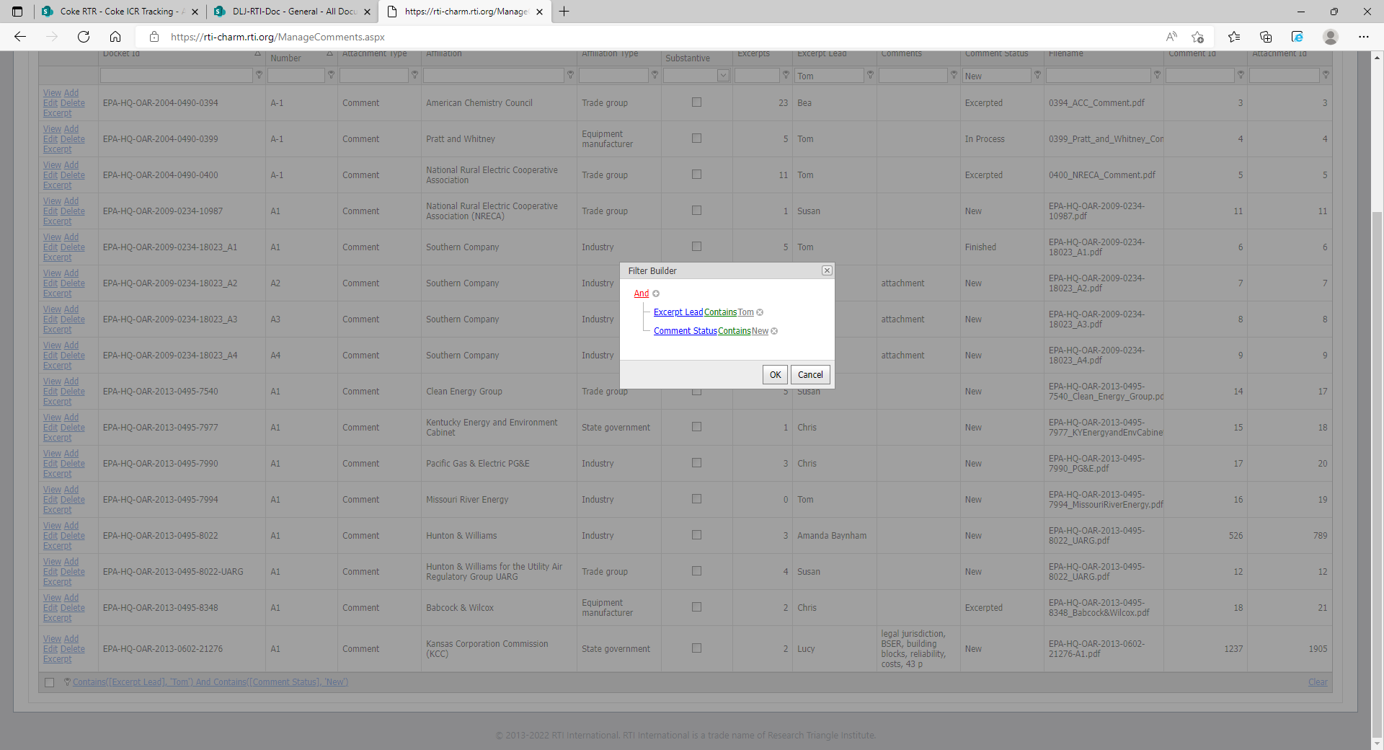

The results of filter on two columns output four comments that were assigned to Tom and are New.

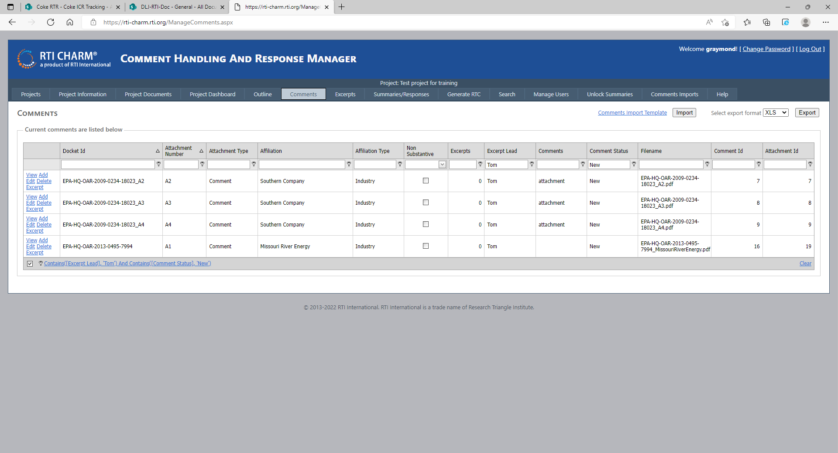

# Outline Tab

The Outline tab is where the document outline is developed and modified, summary and response lead assignments are made, and tracking is done. Keywords, Preamble Section, FR Page No., Rule Section, and Comment fields can be used to guide excerpters when placing excerpts into sections.

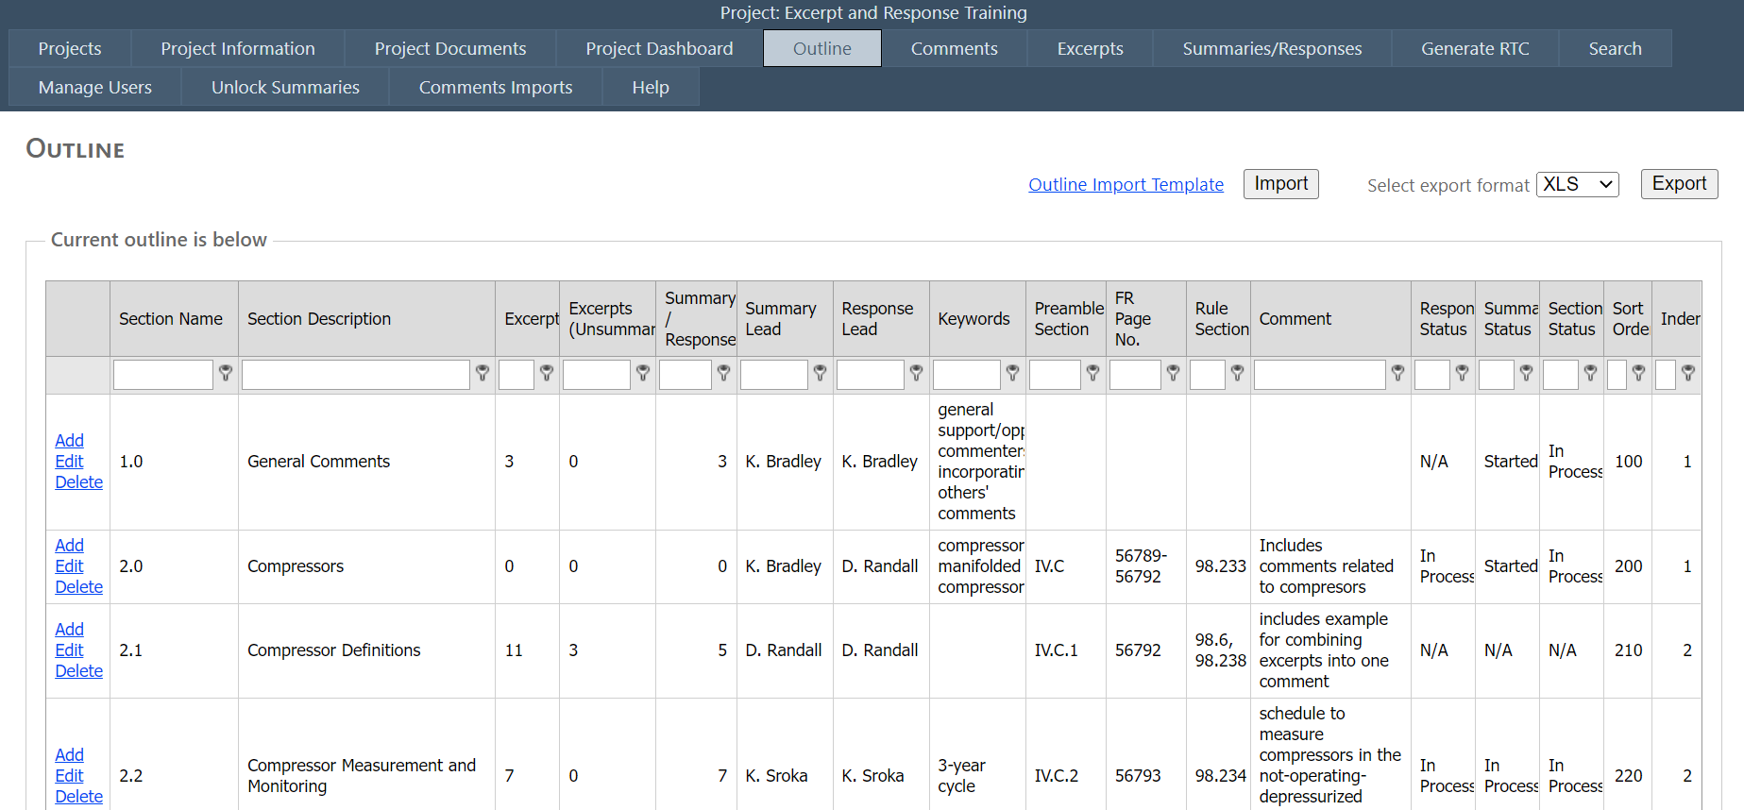

The RTI CHARM tool outline will ultimately be the RTC table of contents, but during the excerpt and summary/response process the outline table allows for tracking, work assignments, and section-specific information.

Columns used for tracking:

* Excerpts (the number of excerpts in the section)
* Excerpts (unsummarized) (the number of unsummarized excerpts in the section)
* Summary/Responses (the number of summary/response entries)
* Status fields for Section, Excerpt, Summary, and Response

Columns used for assignments:

* Summary Lead
* Response Lead

Columns used as guides:

* Keywords
* Preamble Section
* FR Page No.
* Rule Section
* Comments (entered and updated in the Manage Outline Add/Edit Form)

## Adding or Editing an Outline Section

Outline sections can be added using the Outline Import Template or manually added one at a time. To add manually, use the Add and Edit links that appear on each row. Delete links are available to Administrators only. The Add and Edit links open the Manage Outline window to allow addition of, or edits to, outline sections or subsections. Each outline section or subsection appears on a separate row within the Outline tab.

For example, to add an outline section, from the Outline tab, left click on any of the add links:

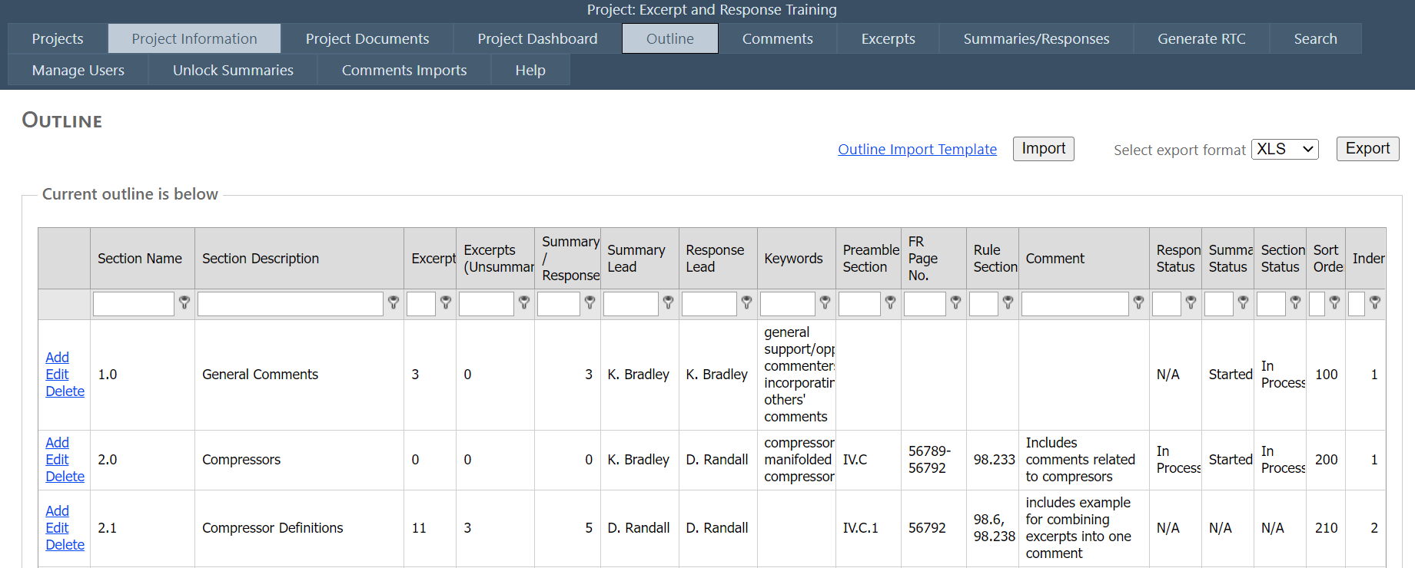

The Add link will open a blank Manage Outline Add/Edit form:

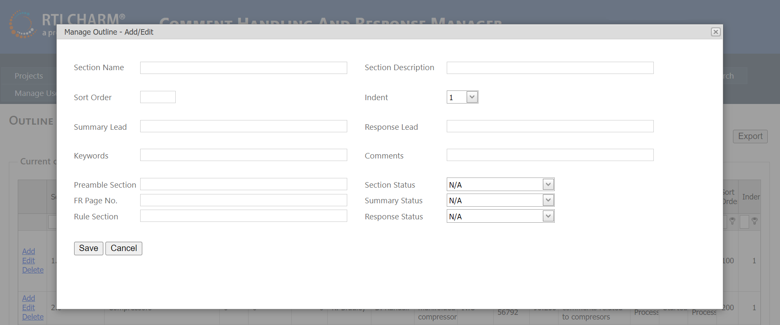

The fields in the Manage Outline Add/Edit form and their purpose are as follows. Several of these fields are optional. RTI project managers will provide instructions for using the optional fields depending on project-specific conventions.

| **Field** | **Purpose** | **Required** |
| --- | --- | --- |
| Section Name | Section number that appears in the RTC document | Required |
| Section Description | Section name/description that appears in the RTC document heading |  |
| Sort Order | Sort Order to order each section from 1 to N in the RTC document. Two sections with the same number will be listed one after the other. It is recommended that sort order numbers be spaced so that new sections can be added without a lot of renumbering. For example, Section 1.0 would be given sort order 1, and Section 2.0, sort order 100. |  |
| Indent | Number of indentions for the outline level in the RTC document printout. Assign an indent level based on the numerals in your section number (i.e., Section 2.0 is indent 1; Section 2.2.2.2 is indent 4). CHARM will use this when generating the RTC to determine the Word document formatting and table of contents. |  |
| Summary Lead | People assigned to develop summaries in the section | Optional |
| Response Lead | People assigned to develop responses in the section |  |
| Keywords | Keywords that an excerpter, summarizer or responder may find helpful when assigning excerpts to the various outline sections. |  |
| Comments | Useful for any unique call-outs applicable to the outline section that Project Administrators may want excerpters and summarizers to know. |  |
| Preamble Section | Status fields that may be used by project teams for tracking the status of sections. Menu choices include N/A, Table of Contents (TOC), Started, In Process, and Finished |  |
| Section Status |  |
| FR Page No. |  |
| Summary Status |  |
| Rule Section |  |
| Response Status |  |

## Deleting an Outline Section

In the Outline table, left click the Delete link to remove a section. The section must be empty; otherwise you will get an error message. You will need to remove or delete the section's contents before it can be deleted. Only administrators have access to the Outline Delete function.

## Temporary Outline Sections

Once comment summarizers begin reviewing excerpts, they may find that excerpts sometimes need to be moved, split, or deleted in the case of a duplicate or off-topic comment. Temporary sections may be used within the outline to allow for movement of excerpts. Examples of temporary sections are shown below.

Machine generated alternative text: Legal 10
Legal — moved from other 12
section
Legal — unassigned to 15
subsection
Applicability of CAA [
Requirement to Establish Rule 100
INSPS Development 1150
NSPS Dey. - moved from other 152
section
NSPS Dey. - unassigned to 155
subsection
Duplicate - delete
Section Name
1.0
1.0 temporary
Section Description
Sort Order
1 . 0 temporary
__ -
11.2
2.0
2.0 temporary
50
2.0 temporary
100.0
150.0
‘Unrelated topic
1500
1550

Temporary sections will be removed from the outline at some point, usually after responses have been drafted and excerpts no longer need to be moved.

## Outline Printout

The Export button at the top right of the Outline screen can be used to generate a copy of the Outline table in .csv, .xls or .xlsx format.

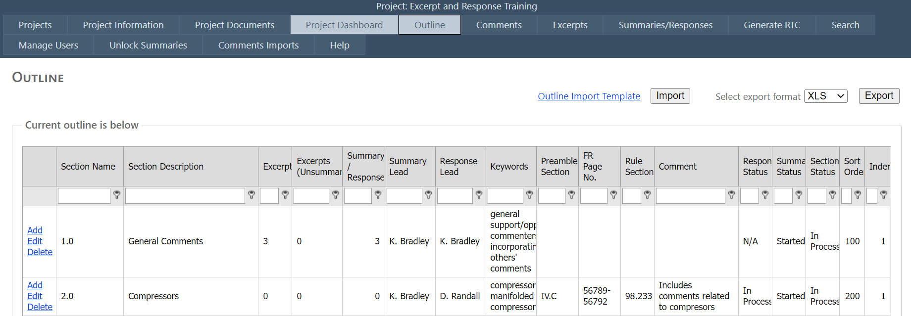

# Comments Tab

The Comments tab is where comment letters are organized and is where excerpting of text from comment letters begins. The project manager can use the Comments tab to make excerpter assignments and track progress.

Comments table:

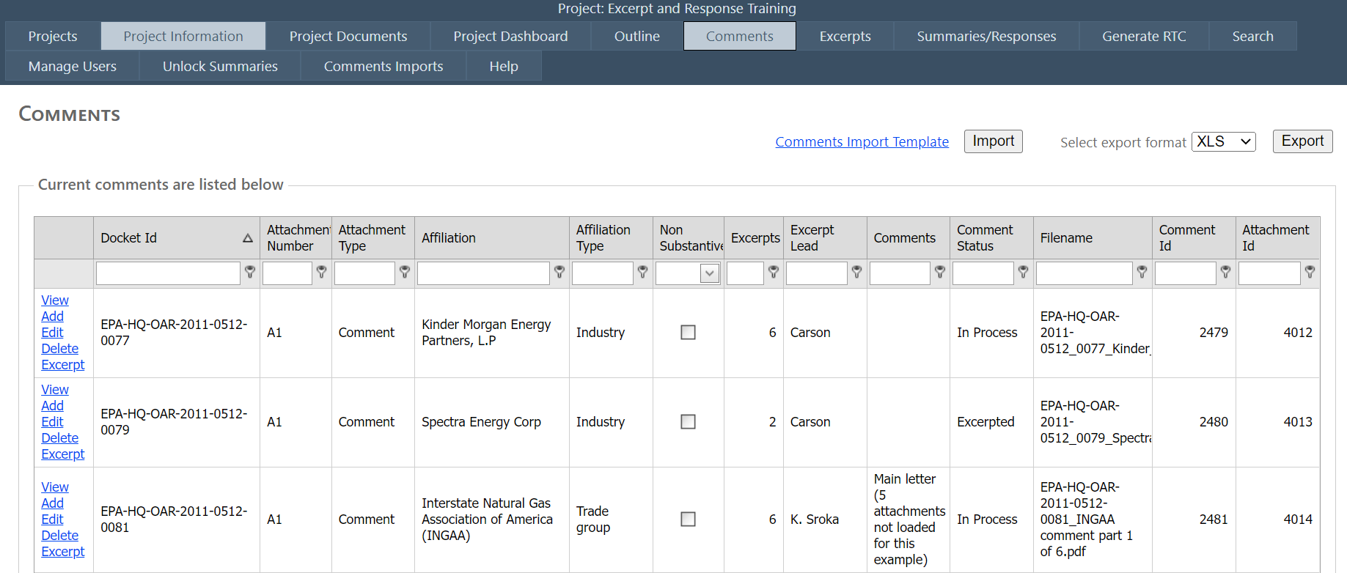

Columns in the Comments tab include the following:

| **Field** | **Purpose** | **Required** |
| --- | --- | --- |
| Comment ID | Unique ID column for the RTI CHARM tool internal use only (so that each comment letter will have a unique ID) | RTI CHARM tool automatically generates |
| Attachment ID | Unique ID column for the RTI CHARM internal use only (so that each comment letter attachment will have a unique ID) |
| Excerpts | The RTI CHARM tool populates this field with the number of excerpts generated from each comment letter or comment attachment. Generally, larger comments have a greater number of excerpts. |
| Docket ID | The full *Regulations.gov* docket ID. | Required |
| Attachment Number | Some docket entries have one or more attachments associated with a single comment letter and docket ID. |
| Attachment Type | e.g., Comment, Cover Letter, Attachment |
| Affiliation | The docket will provide the comment letter's author and affiliation. The affiliation is the company or organization the comment author represents. |
| Affiliation type | This field categorizes the affiliation. Affiliation types include:  Academia, Citizen, Environmental, Equipment manufacturer, Federal government, Industry, Interest group, Local government, nonprofit, Other, Regional, State government, Trade group, and Vendor |
| Excerpt Lead | Excerpt Lead should add their name to prevent overlap of excerpt work. |
| Comment status | As comment letters are entered and excerpted, the status field can be used to track comment excerpt progress. Status field choices include:  New, In Process, Excerpted, Summarized, Response, Finished, Remove |
| Filename | The file name of the document saved on RTI’s server |
| Comments | Can be used to make assignments, add notes, etc., at the project manager’s discretion | Optional |
| Non-Substantive (check box) | Checked for non-substantive comments. Unchecked for substantive comments. The default is unchecked. |

Each row of the Comments tab contains links that allow you view, add, edit, or excerpt comments.

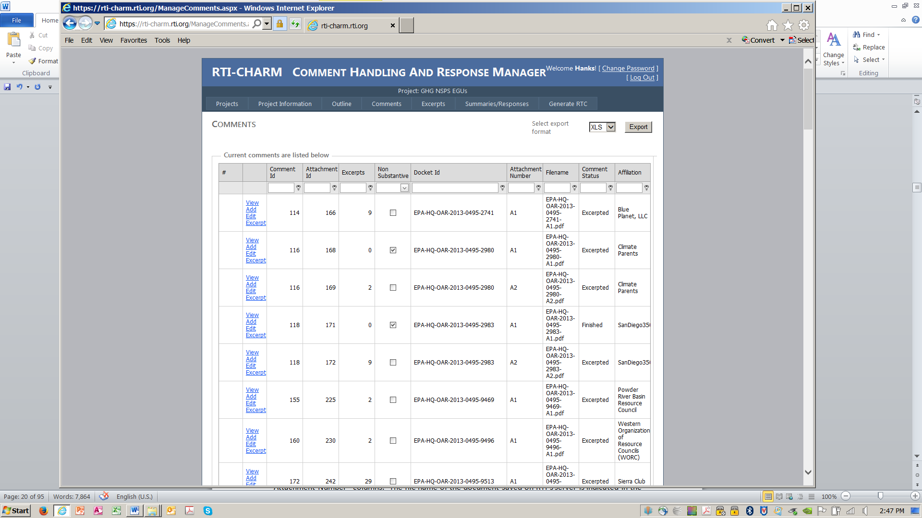

## View a Comment

Use the View link to pull up a pdf of the comment letter in a separate window.

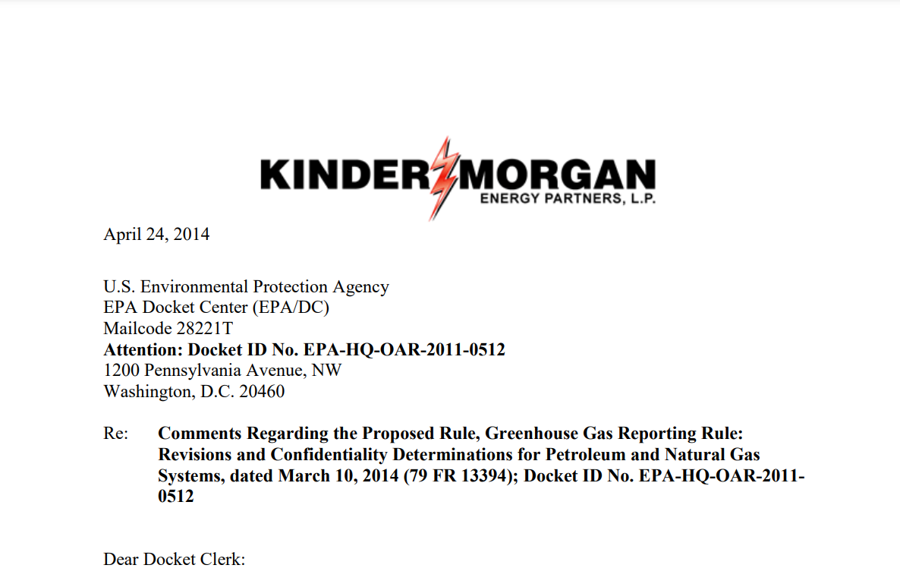

## Adding Comments to the RTI CHARM Tool

The RTI project manager or the RTI CHARM Tool Coordinator is responsible for uploading comments into the RTI CHARM tool database. For projects with thousands of form letters and non-substantive comments (e.g., 10,000 comments), the project manager may elect not to include all of the form letters or non-substantive comments in the Comments table to avoid cluttering the system. Comments are screened for uniqueness and substance prior to upload into the RTI CHARM tool.

Most comments will be entered as a bulk upload early in the comment summary process. There is the Comments Import Template available to Project Administrators who would like to upload their comments in a bulk manner. Contact the RTI CHARM Tool coordinator if you have any questions regarding the use of the bulk upload tool (Lisa Scruggs, 919-316-3745, lkscruggs@rti.org).

Note that some important comments may be posted early, or the Docket Office may take weeks to post all comments, and some comments may need to be entered in the comment database manually.

To add a comment manually, click “Add” and the Manage Comments Add/Edit form opens.

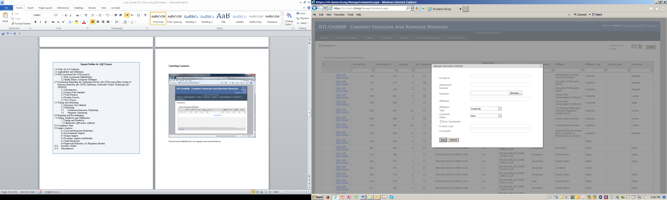

## Editing Comment Information

Open the Manage Comments Add/Edit form as shown above and edit the information provided for each comment.

## Deleting a Comment

The RTI project manager or the RTI CHARM tool coordinator is responsible for uploading comments into the RTI CHARM tool database and has access to remove comments. General users are not allowed to remove comments from the RTI CHARM tool. Please contact the RTI CHARM tool coordinator (Lisa Scruggs, (919) 316-3745, [lkscruggs@rti.org](mailto:lkscruggs@rti.org)) if you believe a comment needs to be removed.

## Updating the Comment Status Fields

The project manager will specify conventions for using the comment status field. Excerpters can update this field to track their progress through comments assigned to them.

## Entering Excerpts

Entering excerpts begins in the [Comments tab](onenote:#Comments%20Table&section-id={530E3311-3ED6-4A40-ADCD-2DA9DB11613B}&page-id={E3EA30CA-646B-43B8-9515-FC26A15ABDB3}&object-id={75D28BB6-043C-4F80-B728-FC2267F36CC3}&21&base-path=rtifile02\ehe\Projects\0271300.107-Comments_DB\Technical_Record\Documentation\C). That is where you will select the comment letter that you will be excerpting. Use the Excerpt link in the far left column of the Comments table to begin excerpting.



If excerpts have been created from a comment, the number of excerpts will appear in the Excerpts column of the Comments tab. A detailed list of the excerpts for a specific comment will appear in a comment excerpts table when you click the Excerpts link in the Comments tab for that comment:

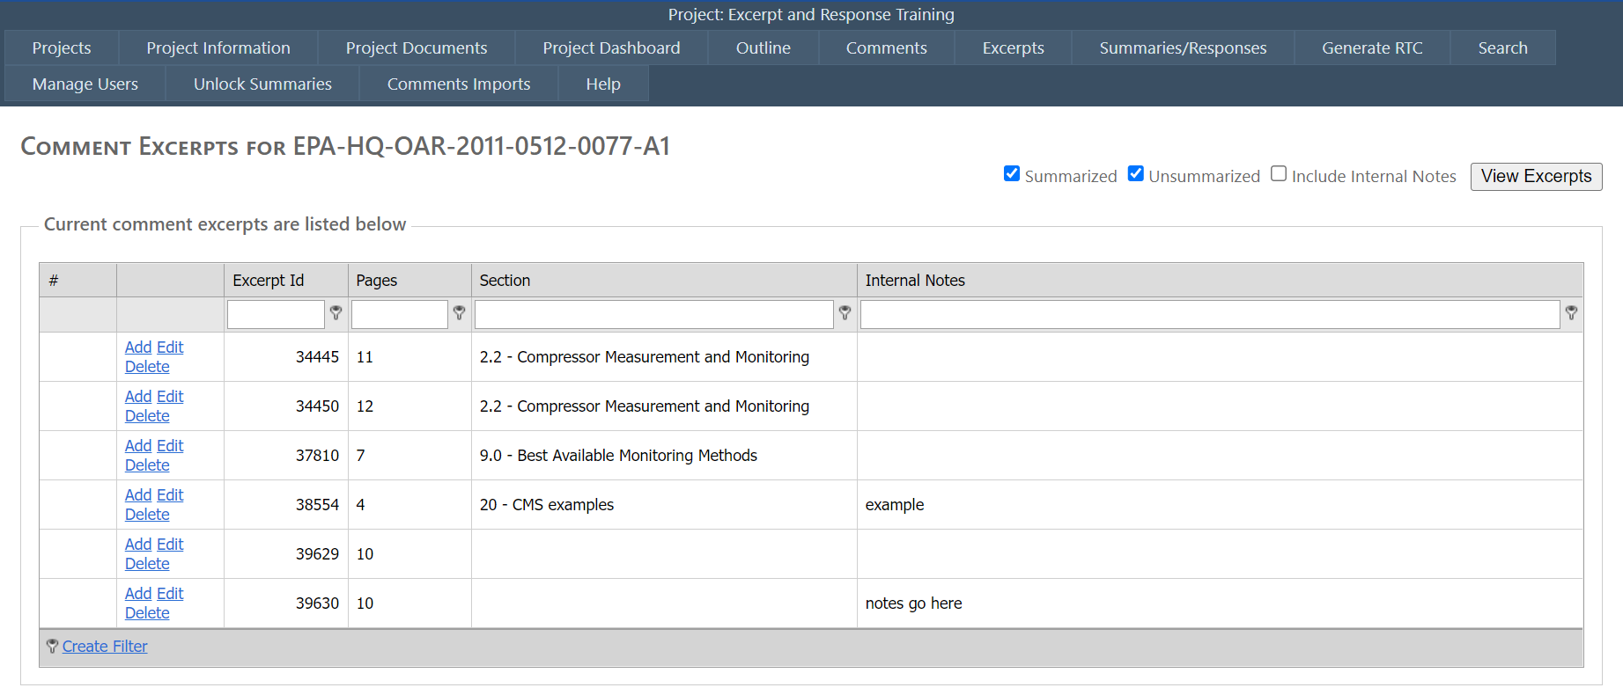

You can create a new excerpt by clicking on any of the Add links. If you would like to view the current excerpts for a comment, you can use the “View Excerpts” tool at the top right of the screen. You can check the boxes labeled “Summarized”, “Unsummarized”, and “Include Internal Notes” checkboxes to view specific excerpts and to toggle the inclusion of the internal notes located in the “Internal Notes” column visible on the far right.

If no excerpts have been created from a comment, the comment excerpts screen appears as follows. Click on Add Comment Excerpt to add a new excerpt.

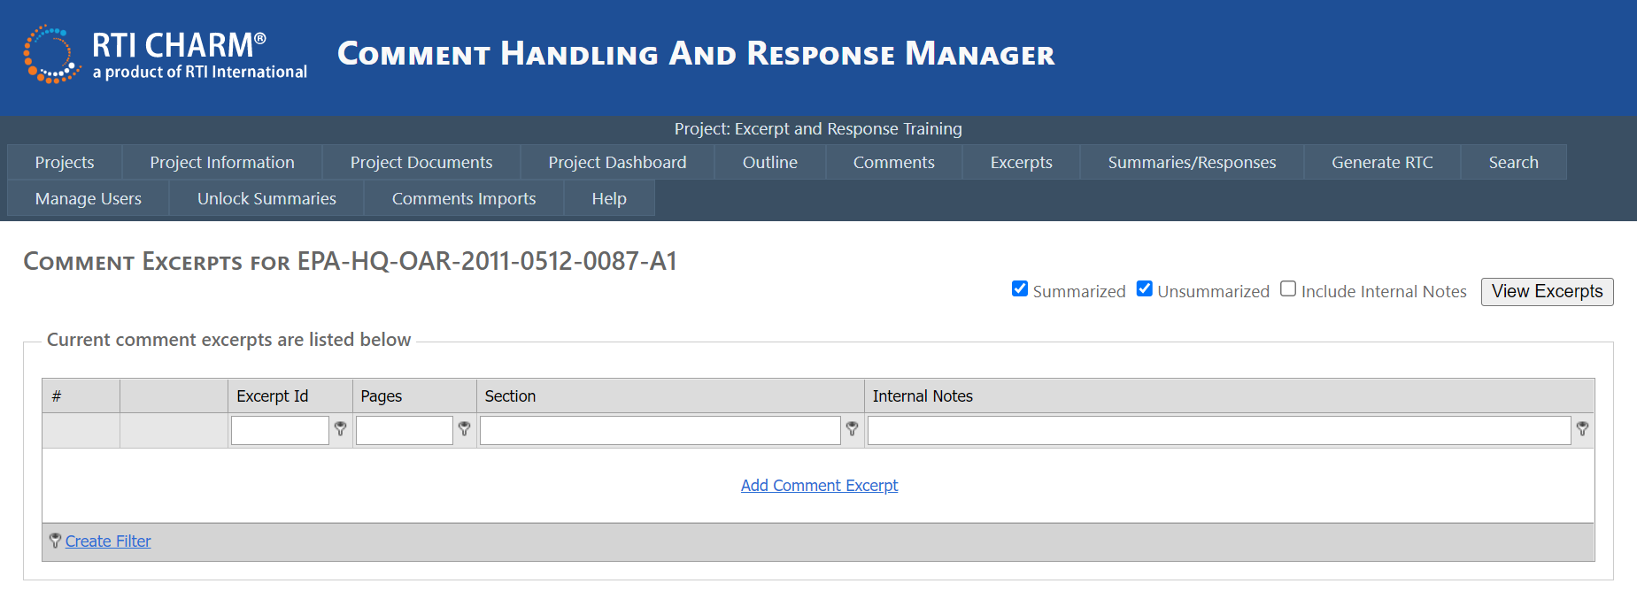

 The excerpt entry form appears as follows:

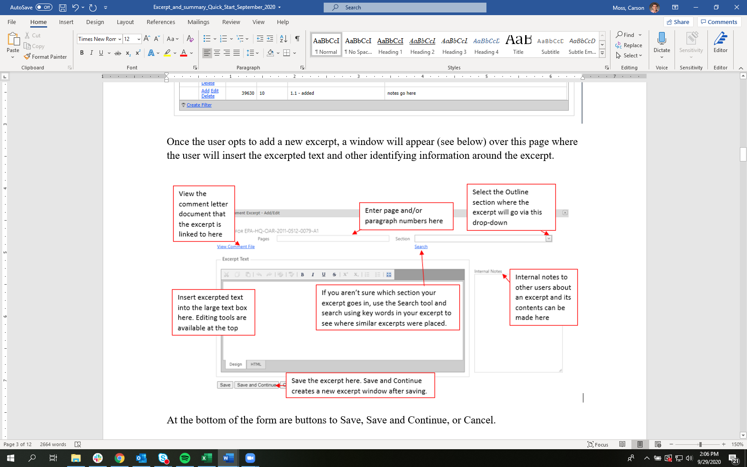

Excerpt text should be typed or copied into the excerpt text box in the entry form. In many cases, excerpt text will be pasted from a pdf file and will require cleaning up and removal of hard returns (similar to when pdf text is pasted into Word). See *Working with pdfs (Tips for Excerpters)* below for best practices. Like other text boxes in the RTI CHARM tool, the Excerpt text box provides some basic formatting options to aid in text clean-up.

The Excerpt text box also provides an option to view text in HTML which can help with identifying hidden formatting that may have been copied into the text box. However, you will compile your excerpt in the Design box. For more information on use of the HTML text box, see *HTML Functions* below.

Once you have entered and cleaned up each excerpt, click Save. Click Save and Continue if you have other excerpts to enter from the same comment letter. Hit Cancel if you wish to leave the excerpt without saving. A pop-up will appear once the user has selected Cancel asking them if they are sure that they would like to leave the page without saving. Note that once you save an excerpt it will be date and time stamped with your name as the last person editing the response.

## Duplicating Excerpt

Users also have the ability to duplicate excerpts once an excerpt is created and saved into the system. A User may want to duplicate an excerpt for one of two typical reasons: 1) the excerpt is something which spans the topic of more than one outline section, and may need to be included in both, or 2) the original excerpt is very long, and actually spans multiple points made by the commenter, and therefore sections of the excerpt may need to be copied and moved to a new excerpt in a different section.

To duplicate an excerpt, go to the Excerpts tab and located the excerpt you would like to duplicate using the outline navigation box. Click on the outline section of interest.

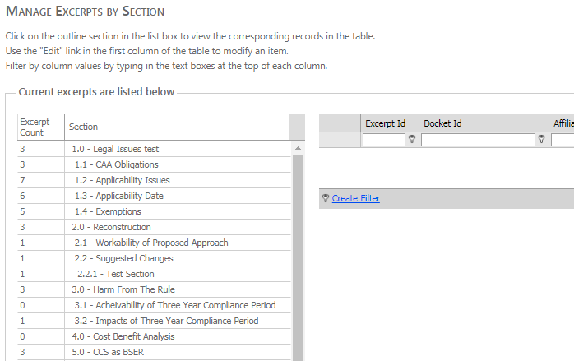

Once you have navigated to the appropriate Outline section, click Edit next to the excerpt you would like to duplicate.

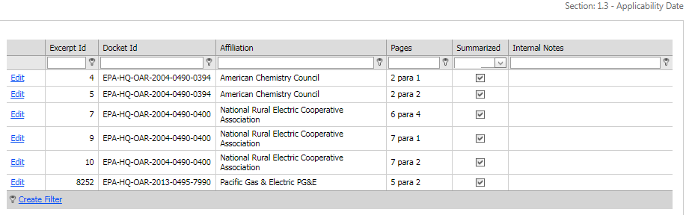

The excerpt window should appear, this time with a new button called Duplicate Excerpt located below the large text box.

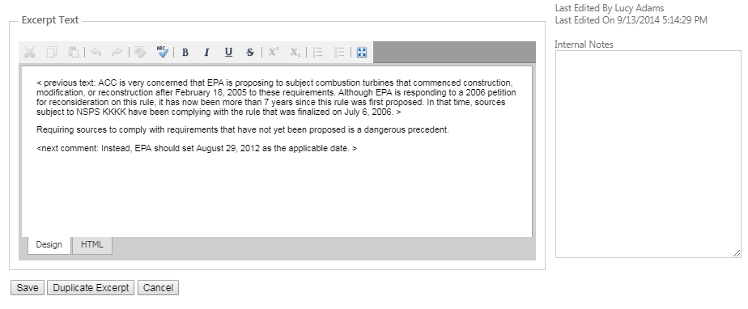

Selecting the Duplicate Excerpt button will create a new Excerpt ID with identical excerpt text and meta information (page number, outline section, etc.) as the original excerpt. The user can edit the text in this text box as they need to for the new excerpt. If the user needs to move the excerpt to a different Outline section, the user can simply select a new Outline section from the drop-down box at the top-right of the Excerpt window. Once the next excerpt has been edited and moved to the user’s needs, the user can select ‘Save’ to save the new excerpt.

# Excerpts Tab

Once excerpts have been created, they are grouped by outline section in the Excerpts tab or by comment letter in the Comments tab.

In the Excerpts tab, excerpts grouped by section can be viewed or edited, you will see a list of the outline sections per project. Click on an outline section to view the excerpts that were assigned to that outline section. You can enter a keyword into the search bar above the outline sections to navigate to a specific section faster.

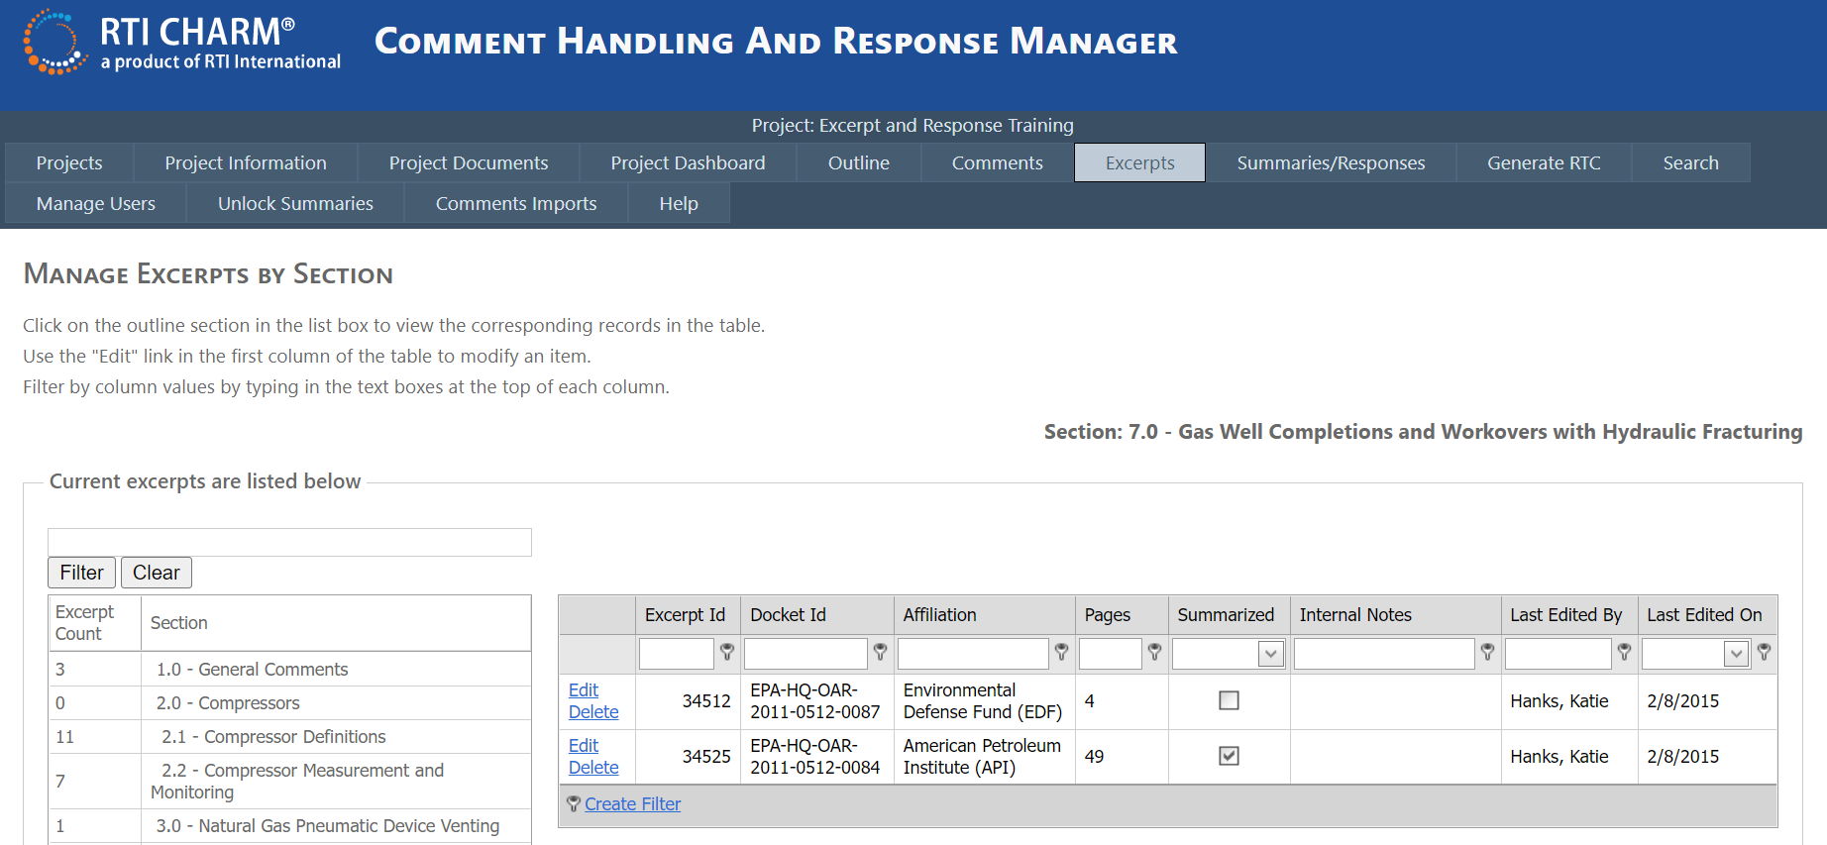

 In the Comments tab, The Comment table displays the number of excerpts created for each comment letter, and the comment status:

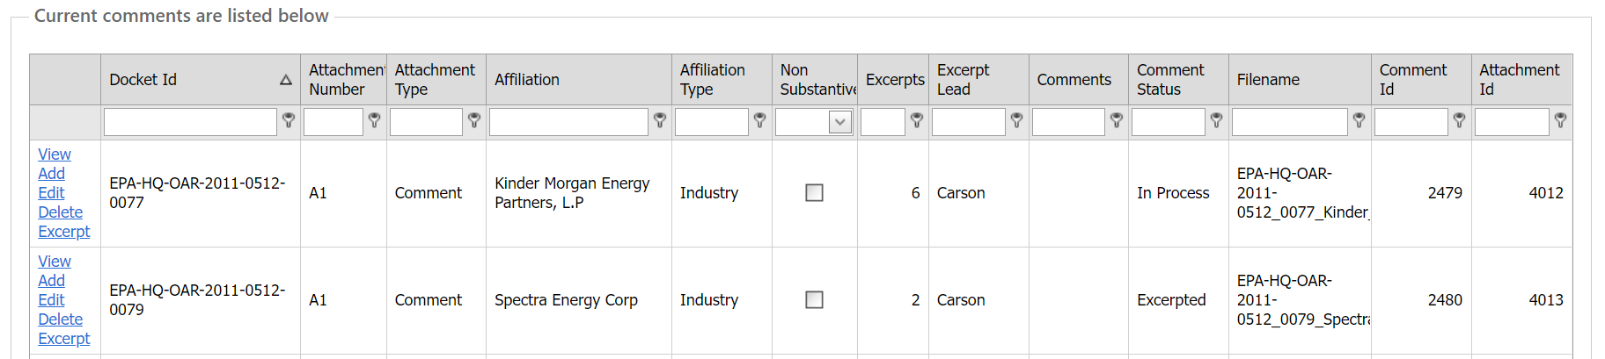

Left click on the Excerpt link for the comment letter of concern, and a table listing the excerpts for the comment letter will be displayed. The Excerpt ID numbers and page numbers should allow you to track which comments were put where in your outline.

You can also use the “View Excerpts” tool to view the text contained in each excerpt, and to see which excerpts have been summarized or remain unsummarized.



# Summaries/Responses Tab

If you are summarizing or responding to comments, you will begin at the Outline tab to identify which sections you are responsible for and then move to the Summaries/Responses tab.

In the Outline tab, use the sort or search feature in either of the Summary or Response Lead columns to identify the outline sections assigned to you.

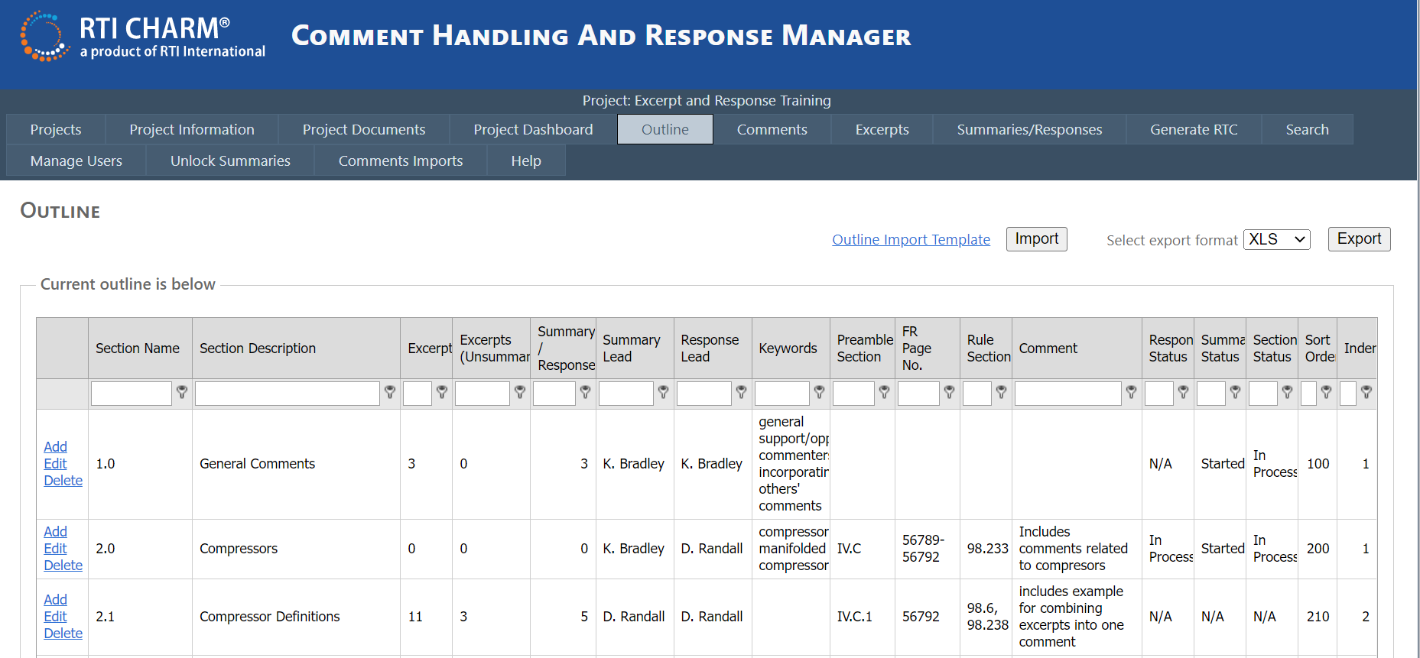

Summaries and responses are accessed through the Summaries/Responses tab.

Select your outline section. You can enter a keyword into the search bar above the outline sections to navigate to a specific section faster. The View Excerpts button will create a Word document with all of the excerpts in your section, which will be a useful reference. You also have the option to view just Summarized or Unsummarized excerpts in the Word document using the checkboxes. If no summaries have been entered, the table will be empty, as above. Left click the Add Summary/Response link to create a new summary or response.

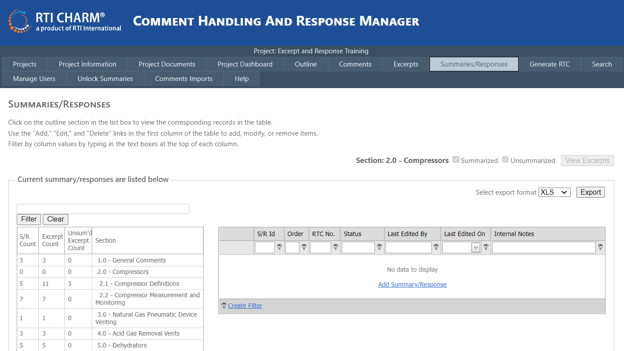

Link opens to a Word file containing summarized, unsummarized, or all excerpts for the highlighted section depending on which checkboxes are selected.

If summaries have been entered, they will be listed in the table (as shown below). The Add or Edit link takes you to each specific summary/response.

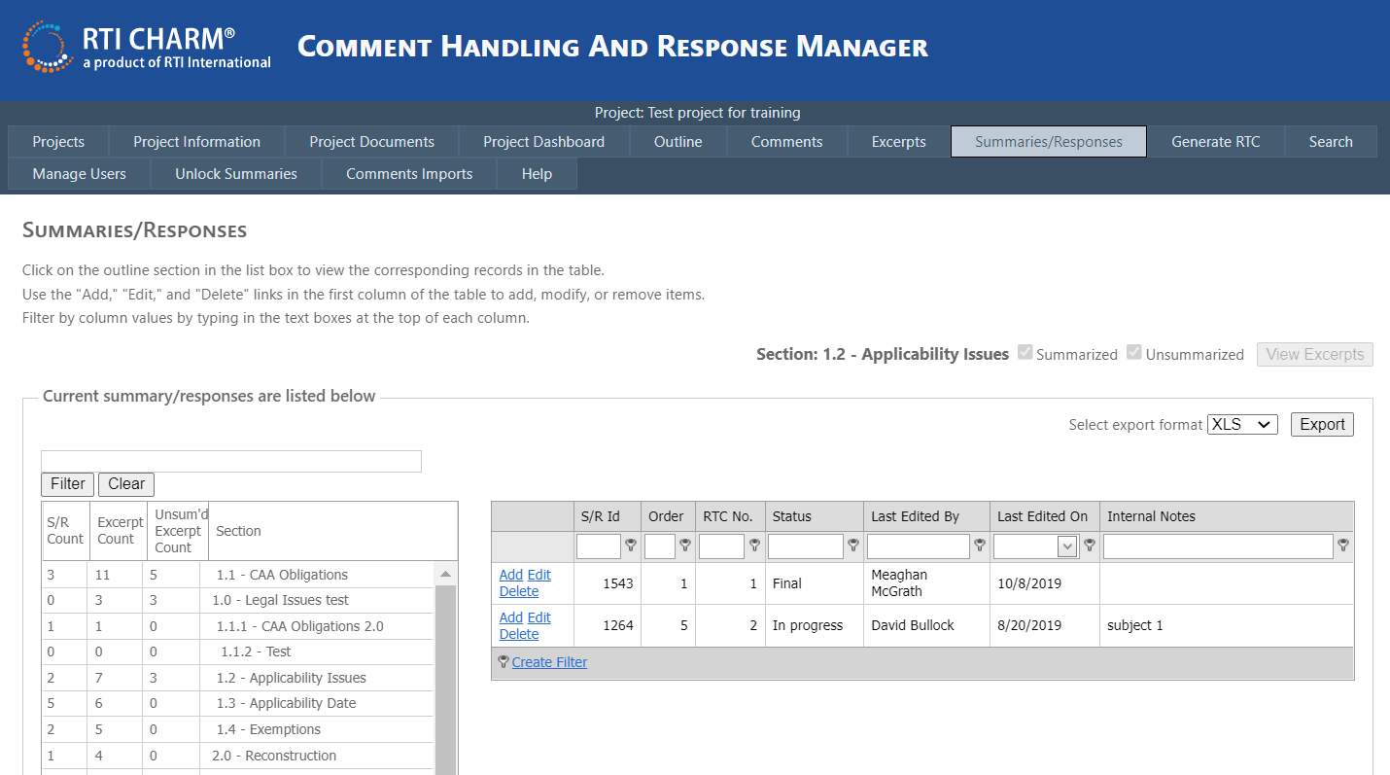

**Notes about Permissions**

The RTI CHARM tool is designed to allow project managers to assign section-by-section editing permission to select users to prevent unauthorized editing of material in the RTI CHARM tool. If you do not have access to edit summaries and responses in a particular section, you will not have the Add or Edit links in the Summaries/Responses. Instead these links will be replaced by a “View” link.

Additionally, the “Delete” link shown above is only available for project or the RTI CHARM tool administrators to prevent accidental deletion of material. If you wish to have a summary/response deleted, please make a note in the summary or response block (e.g., put “<<delete this summary/response from the RTC document because....>>”) and make a note in the Internal Notes field for the summary/response. The RTI CHARM tool coordinator will remove the summary/response at a later date.

The Edit link takes you to the specific summary/response in the Manage Summary/Response window. The Add link will open a window with a blank form that can be used by summarizers to build summaries and by responders to draft responses. For most projects, summaries will be prepared prior to initiation of work in responses.

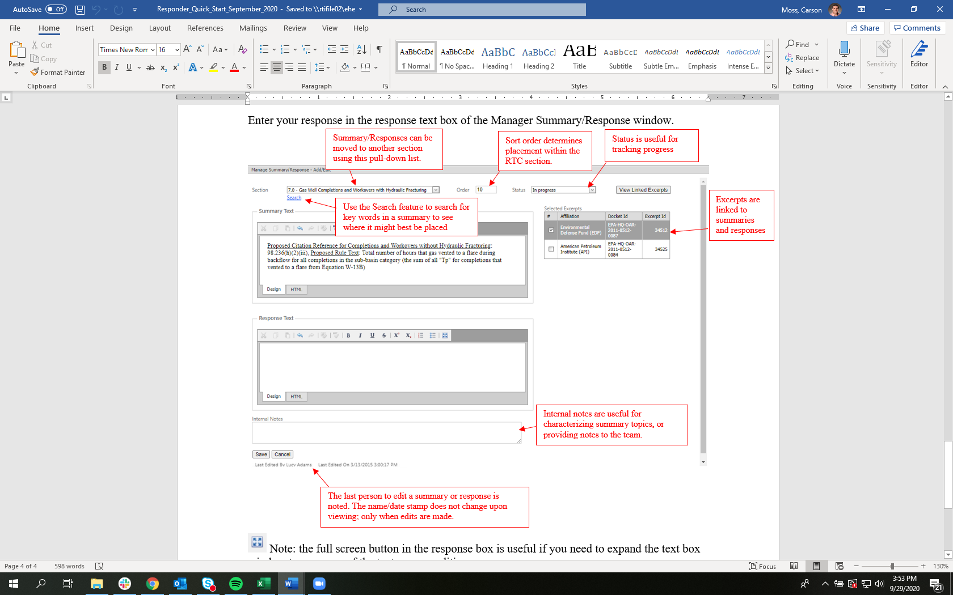

Enter text for the summary and response in the text boxes. See Using the RTI CHARM tool Text Boxes for information on using the RTI CHARM tool text boxes.

## Summary/Response Sort Order

Numbering the summary/response or excerpt determines the order of display in the RTC document section. Summarizers should leave some leeway when entering the sort order. Numbering the summary/responses at intervals of ten (i.e., 10, 20, 30....) will allow for insertion and movement of entries into the order without renumbering.

## Selection of Excerpts When Building Summaries

Multiple excerpts can be grouped and followed by a single response. An excerpt must always be selected for a summary or a response.[[1]](#footnote-1) If you try to save before entering the order and selecting an excerpt, the system will prompt you to enter those items.

## Drafting Responses

When drafting responses to previously developed summaries, responders may view the summary text in the box above the response block, or may find it useful to generate a Word file for their section using the Generate RTC tab (as described in the "Generate Response to Comments (RTC) Document" section of this document). Responders may enter their responses directly into the response text box in the RTI CHARM tool or may elect to craft their responses in the Word file and paste them into the RTI CHARM tool response text box.

## Updating the Status when Summary or Response Work is Complete

The status field in the Manage Summary/Response window applies for each specific summary-response combination. When work on a particular summary-response is complete, use the pull-down menu in the Manage Summary/Response window to update the status field.

When all of the responses or summaries have been completed for a section, update the status fields in the Outline Tab. The status fields in the Outline tab apply for the entire outline section.

## Splitting an Excerpt, Summary or Response

When working on summaries you may find that some excerpts need to be split so the content can be covered in more than one summary. To split an excerpt, use the Comment tab to locate and open the [original excerpt](onenote:#Excerpts&section-id={CB895391-3ABB-44EB-9463-25A2D94577A7}&page-id={05EF6CBB-E693-4F1A-A1E4-D281B7AD9BB8}&object-id={46B633AA-BDA0-4BDB-9B4D-060D2254F8DC}&27&base-path=rtifile02\ehe\Projects\0271300.107-Comments_DB\Technical_Record\Documentation\CHARMComm) to be split.

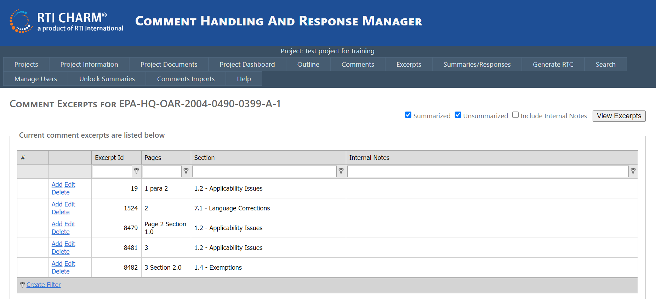

Cut the text to be split from the original excerpt, save the original excerpt, and return to the comment excerpt table. Left click on any of the Add links in the table, and create a new excerpt by pasting the text split from the original excerpt. Save the new excerpt.

Splitting a summary or response is the same type of operation, but uses the Summaries/Responses tab and includes an additional step. A summary or response must be linked to an excerpt, so the original excerpt should be split first before splitting the summary or response. If there is text in both the summary and response text boxes, both need to be cut from the original and saved, in a temporary file. A new summary/response is created, the cut text is pasted in, and the form blanks and lists are completed.

Please contact the RTI CHARM Tool Coordinator (Lisa Scruggs, (919) 316-3745, [lkscruggs@rti.org](mailto:lkscruggs@rti.org)) for assistance with splitting summaries and responses.

## Moving Excerpts, Summaries and Responses

It is best to have excerpts sorted into correct outline sections before starting summaries or responses. Nevertheless, there may be instances when an excerpt or summary and response should be moved to a different part of the outline.

An excerpt is easily moved by selecting the target outline section from the pull down list in the excerpt add/edit form.

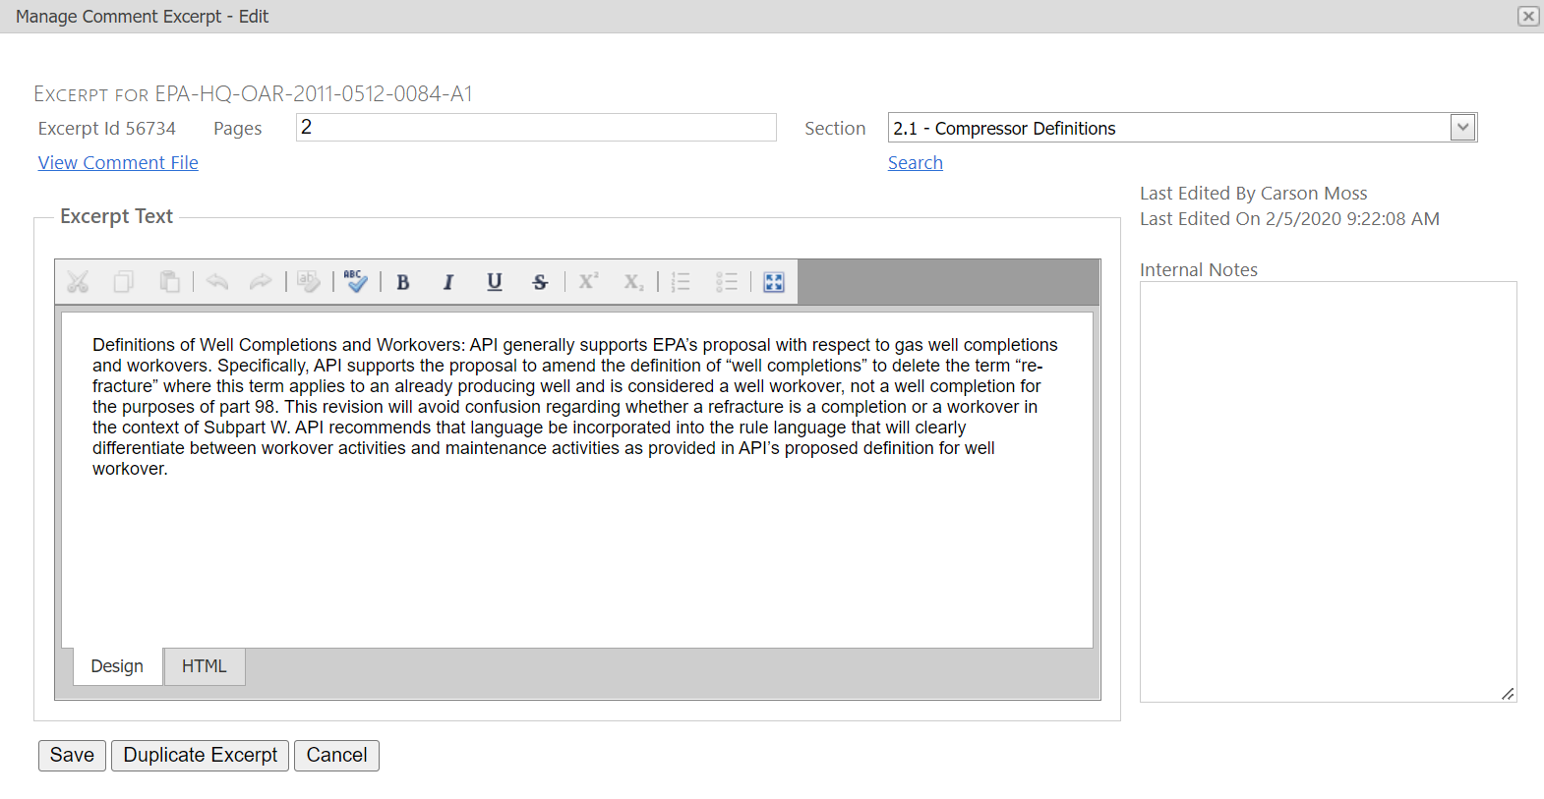

The summary/response moving process requires more steps, including:

* Moving the excerpt first
* Copying the summary/response text fields
* Moving to the new section
* Pasting the information in a new summary/response form
* Selecting the moved excerpt, and selecting the correct status
* Renumbering the sort order, and
* Deleting the old entry.

Please contact the RTI CHARM™ Coordinator (Lisa Scruggs, (919) 316-3745, [lkscruggs@rti.org](mailto:lkscruggs@rti.org)) for assistance with moving summaries and responses.

# Generate Response to Comments (RTC) Tab

The Generate RTC tab is where you can create a Word-formatted Response to Comments (RTC) document that you can save or print.

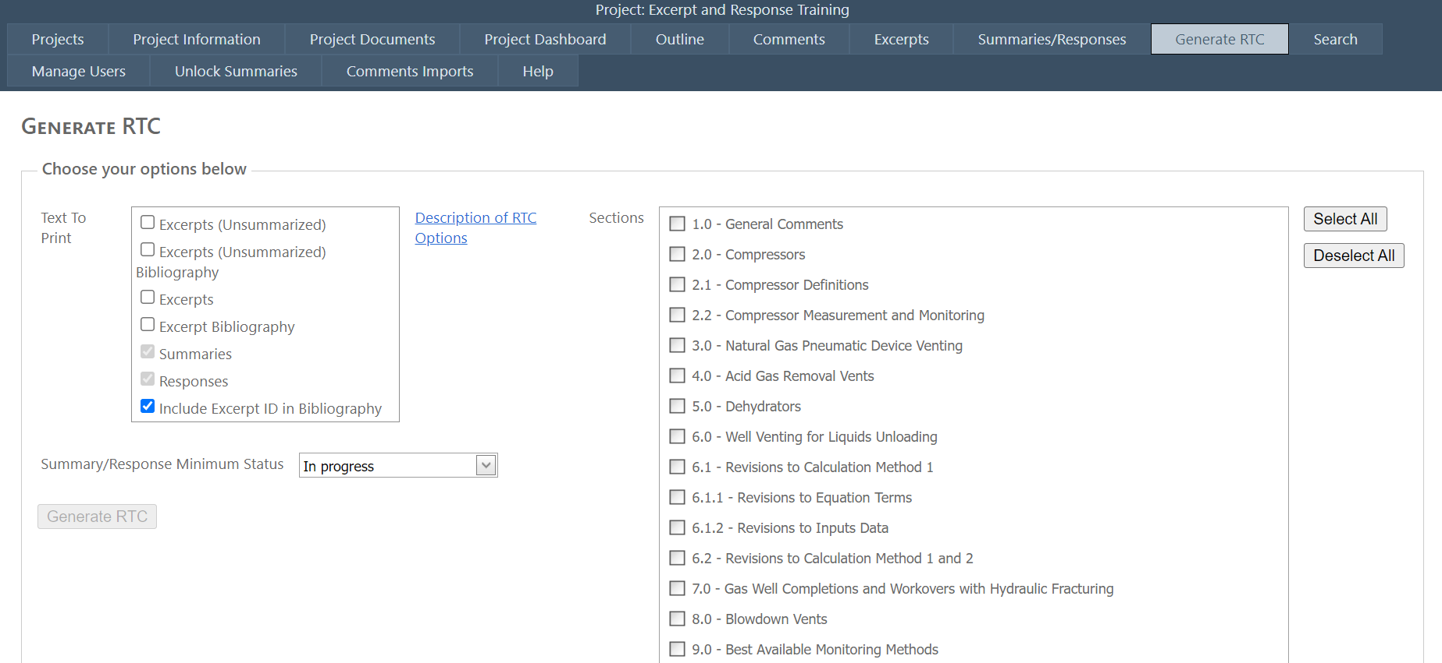

You may select one or more outline sections to include in the RTC document you create. Use the check boxes found next to each outline section to choose the RTC document outline sections you wish to include in the RTC document you save or print. Use the Select All button to include all sections. Use the Deselect All button to remove your selections.

You may choose which text to print in the RTC document you generate. The default selection includes Summaries and Responses because most final documents will only include summaries and responses. However, if you are an RTI CHARM tool summarizer, you may wish to generate a document containing excerpts. If you are a summary reviewer, you may wish to see excerpts along with the summaries and responses. You have the option to include both summarized and unsummarized excerpts in your RTC document. When generating RTC documents including excerpts it is recommended that you also include the excerpt bibliography because this provides information about the commenter (e.g., affiliation, page of the comment letter). The more text you include in the document, the longer it can take to generate.

Example of RTC document containing only Summaries and Responses:

2.1.2 Requirements Under CAA 111

Comment: Commenter 10106 stated that while it has been argued that there is limited commercial use of CCS for power plants, widespread commercial use is not a requirement to set standards under Section 111(b) of the Clean Air Act. Commenter further stated that it is plainly true that such widespread commercial use is not currently present only because these proposed rules are the first to require EGUs to reduce in carbon emissions.

Response:

Comment: Commenters (9725, 10552 and 10680) stated that the EPA arbitrarily uses two distinct and irreconcilable approaches for developing standards for fossil fueled EGUs. Commenters further stated that the standard proposed for natural gas combined cycle technology is based upon actual emission data from operating units while the standard proposed for coal base load technology is based upon calculations for hypothetical coal units using unproven CCS technologies. Commenters further stated that the result is a standard that can be met by over 95 percent of the operating natural gas combined cycle units and a standard that cannot be met by a single existing coal base load unit, even those using newest and most advanced coal based technologies such as SCPC or IGCC.

Response:

Example of RTC document containing Excerpts, Summaries and Responses without the Excerpt Bibliography:

**2.1.2 Requirements Under CAA 111**

**Comment:**  While it has been argued that there is limited commercial use of CCS for power plants, widespread commercial use is not a requirement to set standards under Section 111(b) of the Clean Air Act. Additionally, it is plainly true that such widespread commercial use is not currently present only because these proposed rules are the first to require EGUs to reduce in carbon emissions.

**Comment:** Commenter 10106 stated that while it has been argued that there is limited commercial use of CCS for power plants, widespread commercial use is not a requirement to set standards under Section 111(b) of the Clean Air Act. Commenter further stated that it is plainly true that such widespread commercial use is not currently present only because these proposed rules are the first to require EGUs to reduce in carbon emissions.

**Response:**

Example of RTC document containing Excerpts, Summaries and Responses with the Excerpt Bibliography (Note: Some text was omitted to fit this example in one page):

2.1.2 Requirements Under CAA 111

Commenter Name:  Keith Reopelle   
Commenter Affiliation: Clean Wisconsin   
Comment Number: EPA-HQ-OAR-2013-0495-10106   
Page(s): 1 para 3

Comment:  While it has been argued that there is limited commercial use of CCS .........

Comment: Commenter 10106 stated that while it has been argued that there is limited commercial use of CCS for power plants, widespread commercial use is not a requirement to set standards under Section 111(b) of the Clean Air Act. ........

Response:

Commenter Name: Deck S. Slone   
Commenter Affiliation: Arch Coal, Inc   
Comment Number: EPA-HQ-OAR-2013-0495-10552   
Page(s): 3 paragraph 3

Comment: The development of the standards is arbitrary: .......

Commenter Name: Cason Carter and Dan Barron   
Commenter Affiliation: Alliance Coal, LLC   
Comment Number: EPA-HQ-OAR-2013-0495-10680   
Page(s): 5 paragraph 3

Comment: The development of the standards is unreasoned and arbitrary: EPA arbitrarily uses two distinct and irreconcilable approaches .......

Commenter Name: Everett C. King   
Commenter Affiliation: Ambre Energy   
Comment Number: EPA-HQ-OAR-2013-0495-9725   
Page(s): 3 para 3-4

Comment: EPA arbitrarily uses two distinct and irreconcilable approaches ........

Comment: Commenters (9725, 10552 and 10680) stated that the EPA arbitrarily uses two distinct and irreconcilable approaches for developing standards for fossil fueled EGUs. Commenters further stated that the standard proposed for natural gas combined cycle technology is based upon actual emission data from operating units while the standard proposed for coal base load technology is based upon calculations for hypothetical coal units using unproven CCS technologies. .........

Response:

Response:

Commenter Name: Deck S. Slone   
Commenter Affiliation: Arch Coal, Inc   
Comment Number: EPA-HQ-OAR-2013-0495-10552   
Page(s): 3 paragraph 3

Comment: The development of the standards is arbitrary: EPA arbitrarily uses two distinct and irreconcilable approaches for developing standards for fossil fueled EGUs. The standard proposed for natural gas combined cycle technology is based upon actual emission data from operating units while the standard proposed for coal baseload technology is based upon calculations for hypothetical coal units using unproven CCS technologies. The result is a standard that can be met by over 95 percent of the operating natural gas combined cycle units but which cannot be met by a single existing coal base load unit ? even those using the newest and most advanced coal-based technologies, such as SCPC or IGCC.

EPA rejects basing a coal baseload plant standard on SCPC and IGCC because, according to EPA, those technologies would not provide ?as much emission reductions as practicable.? EPA is incorrect on several points. First, the proposed standard is not achievable so it will not result in any emission reductions let alone practicable reductions. Second, as EPA concedes, a standard based upon SCPC and IGCC would result in 5-20 percent emission reductions. Moreover, the emission reductions would be twice that level ifthe new coal plants replace the oldest existing subcritical plants. These reductions are real, substantial and ?as much as practicable? with adequately demonstrated technology. EPA takes an entirely different approach in setting the standard for natural gas combined cycle technology. EPA does not attempt to seek ?as much reduction as practicable? and instead allows emission levels 20 percent higher than the levels actually achieved by the best performing natural gas units. EPA?s different approaches in setting the coal and natural gas standards cannot be reconciled and, as a result, are unreasonable and arbitrary.

Commenter Name: Cason Carter and Dan Barron   
Commenter Affiliation: Alliance Coal, LLC   
Comment Number: EPA-HQ-OAR-2013-0495-10680   
Page(s): 5 paragraph 3

Comment: ? The development of the standards is unreasoned and arbitrary: EPA arbitrarily uses two distinct and irreconcilable approaches for developing standards for fossil fueled EGUs. The standard proposed for natural gas combined cycle technology is based upon actual emission data from operating units while the standard proposed for coal base load technology is based upon calculations for hypothetical coal units using unproven CCS technologies. The result is a standard that can be met by over 95 percent of the operating natural gas combined cycle units and a standard that cannot be met by a single existing coal base load unit---even those using newest and most advanced coal based technologies such as SCPC or IGCC.

Commenter Name: Everett C. King   
Commenter Affiliation: Ambre Energy   
Comment Number: EPA-HQ-OAR-2013-0495-9725   
Page(s): 3 para 3-4

Comment:

EPA arbitrarily uses two distinct and irreconcilable approaches for developing standards for fossil fueled EGUs. The

standard proposed for natural gas combined cycle technology is based upon actual emission data from operating units while the standard proposed for coal base load technology is based upon calculations for hypothetical coal units using unproven CCS technologies. The result is a standard that can be met by over 95 percent of the operating natural gas combined cycle units and a standard that cannot be met by a single existing coal base load unit---even those using newest and most advanced coal based technologies such as SCPC or IGCC.

EPA rejects basing a coal base load plant standard on SCPC and IGCC because, according to EPA, those technologies would not provide "as much emission reductions as practicable." EPA is wrong at every level. First, the proposed standard is not achievable so it will not result in any emission reductions let alone practicable reductions. Second, as EPA concedes, a standard based upon SCPC and IGCC would result in 5-20 percent emission reductions. Moreover, the emission reductions would be twice that level if the new coal plants replace the oldest existing subcritical plants. These reductions are real, substantial and "as much as practicable" with adequately demonstrated technology. EPA takes an entirely different approach in setting the standard for natural gas combined cycle technology. EPA does not attempt to seek "as much reduction as practicable" and instead allows emission levels 20 percent higher than the levels actually achieved

by the best performing natural gas units. EPA's different approaches in setting the coal and natural gas standards cannot be reconciled and, as a result, are unreasoned and arbitrary.

Comment: Commenters (9725, 10552 and 10680) stated that the EPA arbitrarily uses two distinct and irreconcilable approaches for developing standards for fossil fueled EGUs. Commenters further stated that the standard proposed for natural gas combined cycle technology is based upon actual emission data from operating units while the standard proposed for coal base load technology is based upon calculations for hypothetical coal units using unproven CCS technologies. Commenters further stated that the result is a standard that can be met by over 95 percent of the operating natural gas combined cycle units and a standard that cannot be met by a single existing coal base load unit, even those using newest and most advanced coal based technologies such as SCPC or IGCC.

Response:

Example of RTC document containing Summaries and Responses with the Excerpt Bibliography:

2.1.2 Requirements Under CAA 111

Commenter Name:  Keith Reopelle   
Commenter Affiliation: Clean Wisconsin   
Comment Number: EPA-HQ-OAR-2013-0495-10106   
Page(s): 1 para 3

Comment: Commenter 10106 stated that while it has been argued that there is limited commercial use of CCS for power plants, widespread commercial use is not a requirement to set standards under Section 111(b) of the Clean Air Act. Commenter further stated that it is plainly true that such widespread commercial use is not currently present only because these proposed rules are the first to require EGUs to reduce in carbon emissions.

Response:

Commenter Name: Deck S. Slone   
Commenter Affiliation: Arch Coal, Inc   
Comment Number: EPA-HQ-OAR-2013-0495-10552   
Page(s): 3 paragraph 3

Commenter Name: Cason Carter and Dan Barron   
Commenter Affiliation: Alliance Coal, LLC   
Comment Number: EPA-HQ-OAR-2013-0495-10680   
Page(s): 5 paragraph 3

Commenter Name: Everett C. King   
Commenter Affiliation: Ambre Energy   
Comment Number: EPA-HQ-OAR-2013-0495-9725   
Page(s): 3 para 3-4

Comment: Commenters (9725, 10552 and 10680) stated that the EPA arbitrarily uses two distinct and irreconcilable approaches for developing standards for fossil fueled EGUs. Commenters further stated that the standard proposed for natural gas combined cycle technology is based upon actual emission data from operating units while the standard proposed for coal base load technology is based upon calculations for hypothetical coal units using unproven CCS technologies. Commenters further stated that the result is a standard that can be met by over 95 percent of the operating natural gas combined cycle units and a standard that cannot be met by a single existing coal base load unit, even those using newest and most advanced coal based technologies such as SCPC or IGCC.

Response:

## Formatting the RTC Document

As the response-development process evolves, some formatting may be necessary in the Word document. It is anticipated that the full RTC document will be thoroughly reviewed for formatting, generation of a table of contents, etc., prior to publication of the RTC document in the final rule docket. Nevertheless, some formatting tips that could be helpful during the RTC response drafting stage are noted below.

The RTC Word document generated by the RTI CHARM tool uses Word styles to format section heading levels, excerpt bibliographies (commenter name, organization, docket ID), and comment and response headings. Word Styles allow you to link the RTC's heading styles to Word's Heading 1, Heading 2, etc.

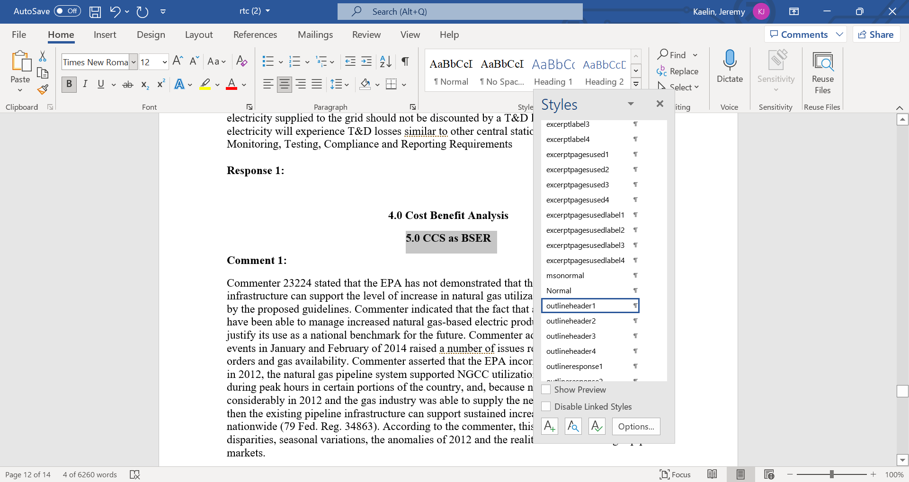

The RTC's section headings are labeled outlineheader1, outlineheader2, etc. Modify the outline header style property, Style Based On, to Heading 1, Heading 2, etc., matching the levels of the section to the Word heading. Matching the sections to the Word Headings allows you to generate a table of contents, and use the document map function in Word.

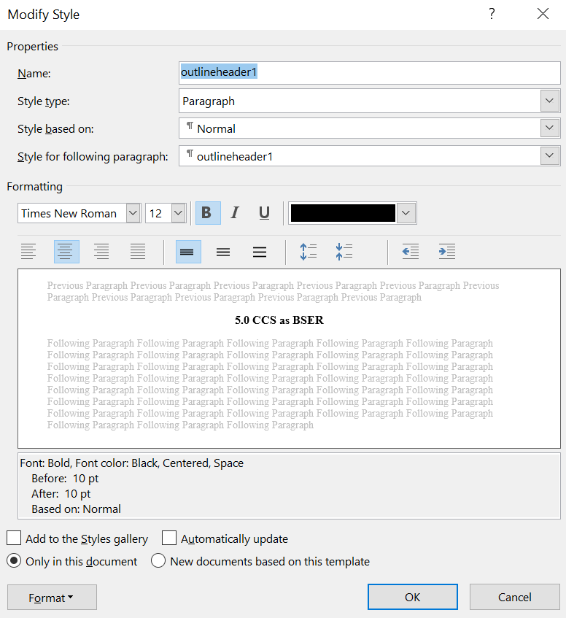

In the same Modify Style window, you can change section styles for your final document.

# Using the RTI CHARM Tool Text Boxes

The RTI CHARM tool includes text boxes for Excerpts, Summaries and Responses. The information in this section will be helpful for all users of the RTI CHARM tool including excerpters, summarizers, responders and reviewers.

## RTI CHARM Tool Text Box Formatting Bar for Excerpts, Summaries, and Responses

The text boxes in the excerpt and summary/response forms have basic word processing functions. The same formatting bar is included in the RTI CHARM tool text boxes used for excerpts, summaries, and responses.



From left to right, this bar includes buttons for cut, copy, paste, undo, redo, remove format, bold, italics, underline, strikeout, superscript, subscript, ordered list, bullet list, and full screen.

 The remove format button can be particularly useful when pasting text from an outside document. The format eraser will remove all formatting, including hidden codes.

The full screen button can also be very useful if you need to expand the text box window to see more of the text you are editing.



The RTI CHARM tool text boxes will recognize any formatting in copied text that is also available on the bar at the top of the text box and will recognize most characters that are on a typical keyboard. Other formatting or characters may appear in the text box but will not print correctly in the RTC Document. Equations, tables and figures will have been noted in the excerpts, but they cannot be successfully imported into the text box.

Many users compose their summaries and responses in word processing software such as Word, and then copy that text into the RTI CHARM tool text box. Word processing can embed code in text that will not be visible in Word or in the RTI CHARM tool’s design view but can be seen in the HTML view. If you insert and copy links, tags, footnotes or comments in your Word text, embedded code may be in the copied text, and should be removed.

The HTML view will help you remove hidden codes. Copying text directly into the HTML view text box will remove hard returns, fonts and styles.

Paragraph break (hard return) codes appear in the HTML view text box as <p> and <p/> for the paragraph break and paragraph end, respectively. Although these and other codes are not visible in the text box, Word recognizes and uses them for text formatting. Look for the paragraph break code at the beginning of a summary or response. If it is not removed, there will be a hard return between the Comment: or Response: headers and the comment or response text. HTML view allows you to remove these and other hidden codes. As your responses are prepared, you may wish to check the printed versions for formatting issues. You may want to go back and fix formatting issues in the RTI CHARM tool text box. Otherwise, RTI will correct formatting issues in the RTI CHARM tool as they are noticed and in the final RTC document developed for publication.

## Tables, Figures, and Equations

The text box does not recognize equations or other non-text objects. Equations, tables and figures may display in the RTI CHARM tool text box but will not convert properly to the Word RTC document. A work around is for excerpters to note comment letter's equations, tables or figures within the excerpt. Often, describing the content or subject of the item and the point it illustrates is all that is needed. The comment summary will use that description with the commenter's ID and the document page number for the responder and RTC document readers.

If you feel that an equation, table, or figure should be included in the RTC document, cut the item from the comment letter, paste it in a Word document, and save it in the designated project file folder. Name the document with the commenter ID and the excerpt number. Note the document name in the excerpt as follows:

<<Add to RTC: Table from EPA-HQ-OAR-2013-0495-0933\_Table\_1.doc>>

This file name information can be carried through the summary to the final RTC document so that that equation, table, or figure can be added to the RTC document upon final formatting.

## Footnotes

Some comment letters contain detailed footnotes that resemble comments. Other comment letters contain footnotes that are simple references to Federal Register notices, court cases, or other studies. Footnotes may be treated as a separate excerpt (if they resemble comments), or added to an excerpt in the text box. In some cases, where the commenter provides a citation, you may only need to note that the citation was provided, either as a reference in a footnote or as an attachment. Or, you may add the footnote as in the example below:

Machine generated alternative text: No turbine manufacturer offers guarantees for NOx emissions below 25 ppm for turbines in
the 30 MW to 50 MW size range. Thus EPA’s statement that a “30 MW cutoff is consistent
with the manufacturer guarantees,” 70 Fed. Reg. at 8318, col. 3, is simply erroneous. While
aeroderivative units might be able to comply with the proposed NSPS if they installed SCR,
EPA estimated the cost effectiveness of such controls at over $6,000/ton, “ which is far
beyond a reasonable cost for an NSPS.
<footnote:  Docket Item 114 (NOx Control Technology Cost Per Ton for Stationary
Combustion Turbines). UARG calculates the cost of controlling NOx from 25 ppm to 9 ppm as
$16,000 to $19,000/ton. Smith Report, Table 6-2, Attachment 1.>

## New Data

Commenters will provide new data in their comments, either in the text of their letters or as attachments. This data must be noted in excerpts where it is discussed, and as a separate excerpt, which will be assigned to a New Data outline section.

## Discussion of Rule Text Changes

Rule text changes are described using the text box's underline and strikeout functions:

Machine generated alternative text: (a)(2) Repairs were made as expeditiously as practically
possible when an a violation occurrcd applicable
emission limitation was being exceeded Off shift and
ovcrtimc labor wcrc iicrrl to thc cxtcnt practical to
make thcc repairs; and

## Spell Check

The word processing functions in the RTI CHARM tool text boxes include spell check, including autocorrect. Please remember that technical terms are not always on spell check lists. Checking for typos will be appreciated.

## Working with pdfs (Tips for Excerpters)

Most comment letters are Adobe pdf documents from which text can be copied, but the text requires some basic formatting whether pasted into Word or directly into a RTI CHARM tool text box such as the Excerpt text box.

Comment letters can be sent as hard copies that are scanned by the docket office, or sent with restrictions that will not allow you to copy text. Some of these documents can be corrected to allow for copying text. The RTI CHARM Tool Coordinator can assist you in saving documents in a form from which you can cut and paste.

Pdf text does not always copy over perfectly. You will most likely need to remove hard returns and correct letters that have not translated properly. Not all characters from a pdf document will copy accurately. Check through the text and correct as you go. Common problems are 1, l, !, / or \ being substituted for each other. Hard returns can be removed by copying text from the pdf into the HTML view, or copying the text to Word, cleaning it up there, and then copying to the RTI CHARM tool. Select all of the text and use the remove format function in the RTI CHARM tool text box tool bar to remove any formatting.

**It is important to remove old formatting.** Non-standard fonts, sizes, colors, etc., will copy into the excerpt printouts for summarizers and responders. Summarizers will appreciate clean text to cut and paste. If you are preparing an excerpt-only RTC, the old formatting will copy into the RTC. The following example illustrates the steps excerpters may need to take to clean up text from a pdf.

Example text from a pdf:

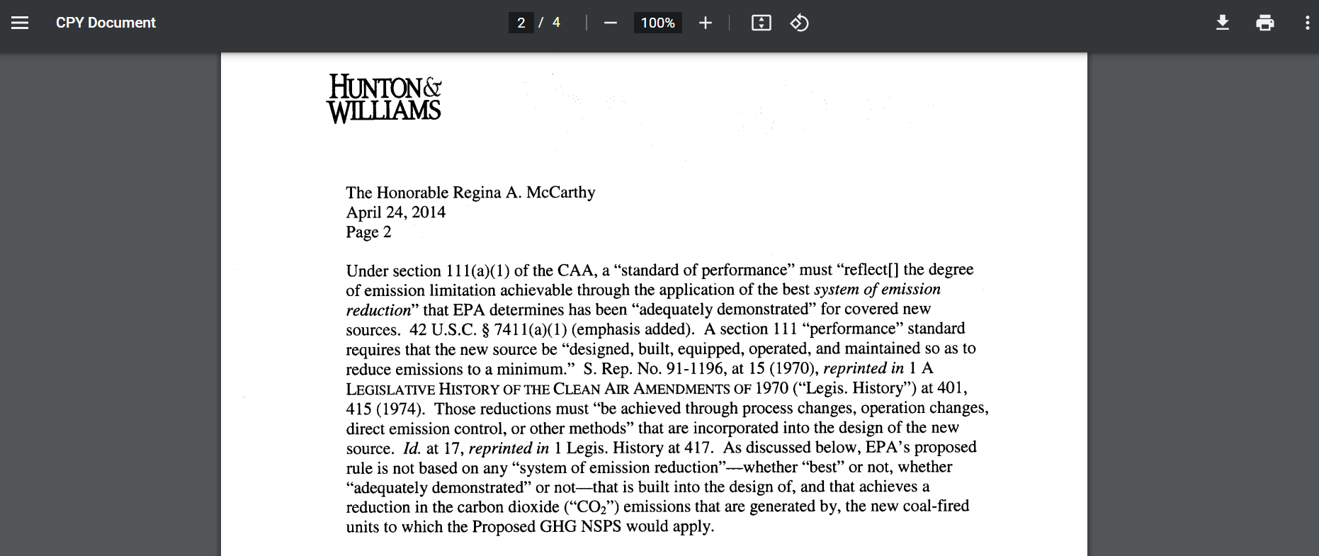

Starting with the copied text above, compare to the pasted text below:

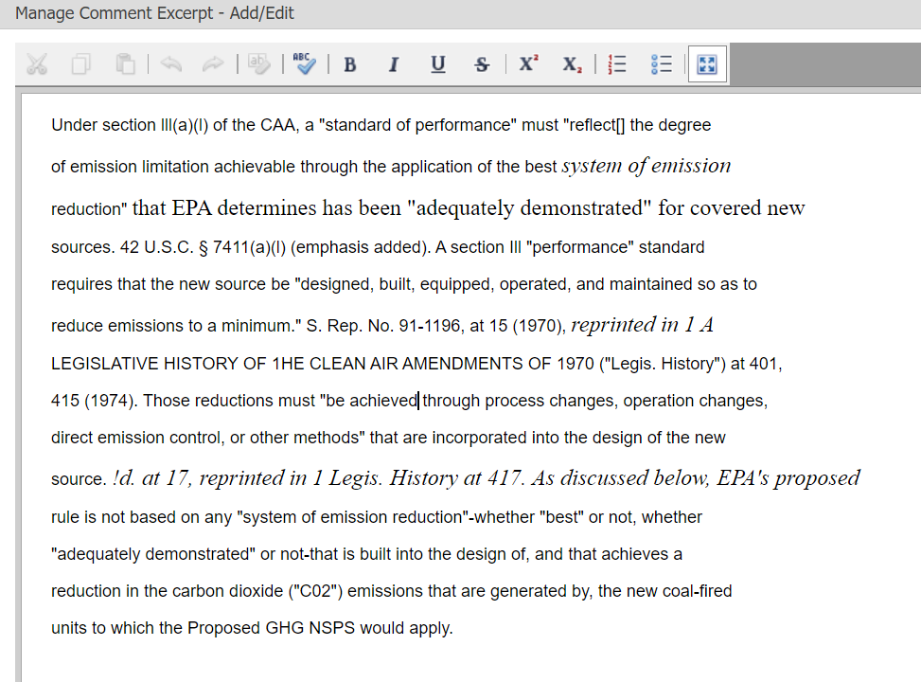

Note that on the first line, section 111 has become section lll (three lowercase L’s). Midway in the paragraph, Legislative History of The Clean Air Amendments is now Legislative History of 1he Clean Air Amendments. Three lines up from the bottom, Id., has become !d. As you excerpt, you will need to read and compare the pasted text to the original pdf.

In addition to correcting copy/paste errors and substituting useable characters for the unreadable characters, remove the carriage returns. The almost-cleaned up text looks like this:

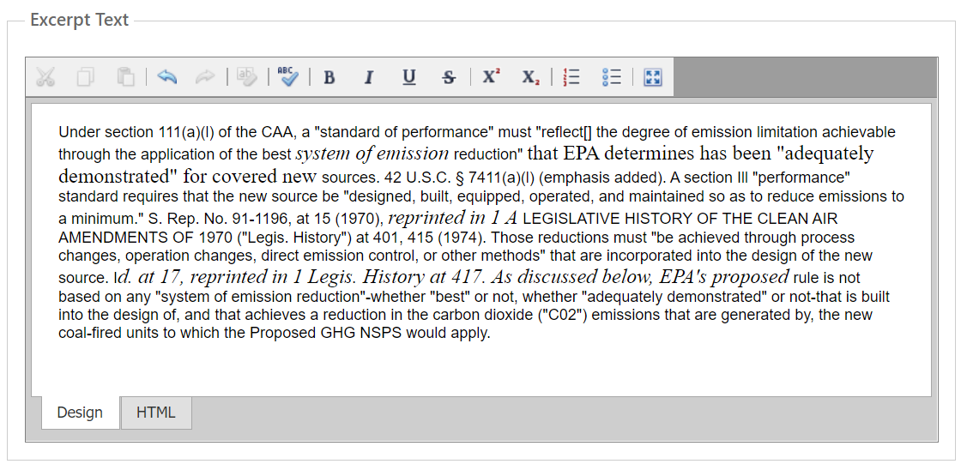

Finally, use the format eraser on the text tool bar to remove the alternating fonts. This will remove italics, use your judgment when putting italics back in. Always use the format eraser, codes can be hidden. If things did not copy and you cannot correct the text, put a note at the top of the text box. The final, cleaned excerpt appears as follows:

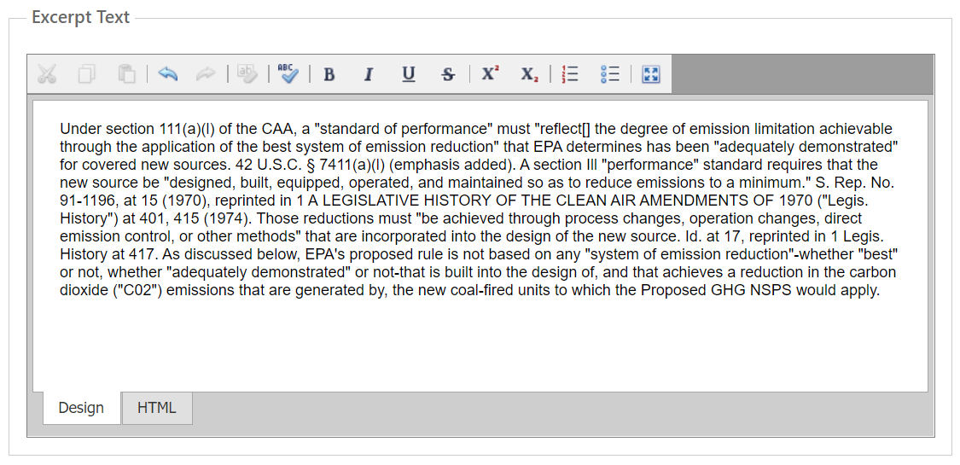

## Inclusion of Surrounding Text in Excerpts for Context

When dividing up excerpts, it can be useful to include surrounding text, even though that text may be using in another summary or in another section. Use < and >, and notes to mark the surrounding and excerpt text:

Machine generated alternative text: <surrounding text included>
<Due to the safety and operational concerns associated with the risk of fuel blow back, the lean
premixing chambers must be bypassed under startup and shutdown conditions where the unit is
operated at less than 50 percent load. When the lean premixing chambers are bypassed under these
conditions, the combustion turbine functions as a standard diffusion flame turbine and does not get the
benefit of the emission-reducing lean premixing process.>
<excerpt:>The same is true for shutdowns and malfunctions. During shutdown, when load is reduced
below 50 percent, the lean premix process ceases to function and the machine reverts to its “diffusion
flame” mode. This results in higher emissions levels of NOx and/or CO.
<During malfunctions, lean premix combustion turbines have an automatic emergency feature that
causes them to temporarily drop out of lean premix mode and operate in previous firing mode until the
malfunction is corrected. Because the turbine is no longer in its lean premix mode, it can no longer meet
emission limitations during a malfunction.>

# Search Tab

The Search tab enables users to search excerpts (unsummarized and summarized), summaries, and responses for key words or phrases.

Users can type in key words or phrases of interest into the Keyword text box and select the areas where they would like to search for the key word or phrase in the check boxes below.

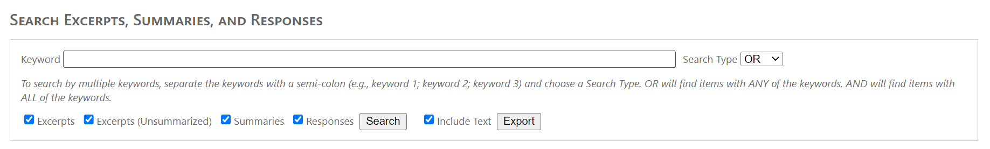

Select Search to execute the search of the key words or phrases. A table will populate below the Keyword box with the applicable results. To export the results to a word file, simply select the Export button directly below the Keyword box.

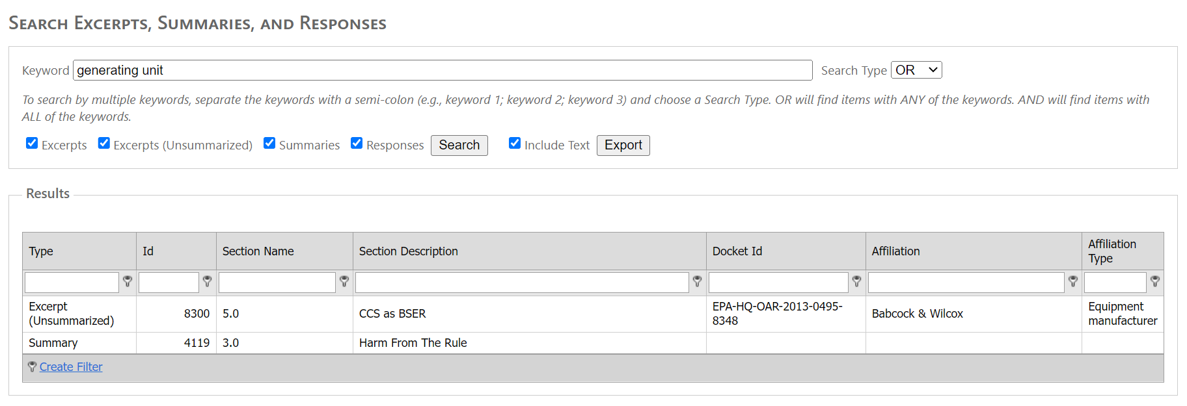

Users also have the ability to search comment files directly for key words.

Select Search to execute the search of the key words. A table will populate below the Keyword box with the applicable results. To export the results to a word file, simply select the Export button directly below the Keyword box.

# Manage Users Tab [only for administrative role]

The Manage Users tab contains a list of all users added to the selected project.

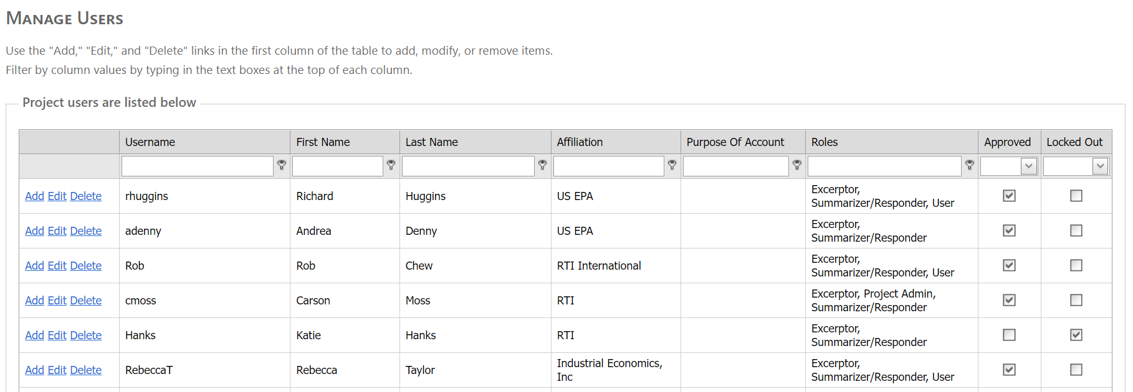

If a user has been approved for the project, a check box will appear next to their name in the Approved column. If the user has been added to the selected project but has not yet been approved, a check will not appear in this column for the user.

If a user has been locked out of the RTI CHARM tool due to a number of failed log-in attempts, this will show via a check in the box next to that user’s name under the Locked Out column.

In order to either grant approval, or removal approval from a selected user, or in order to prevent a user from continuing to be locked out of the project, the Project Administrator(s) should contact the RTI CHARM tool coordinator and inquire about this person’s status.

Project Administrators can assign roles on their project to users in this tab. To assign a user a role, select the Edit button next to that user’s record. Project Administrators can use the search boxes at the headings of each column to search for specific users via their last name, first name, affiliation, or username.

The following screen will pop up on the Project Administrator’s screen:

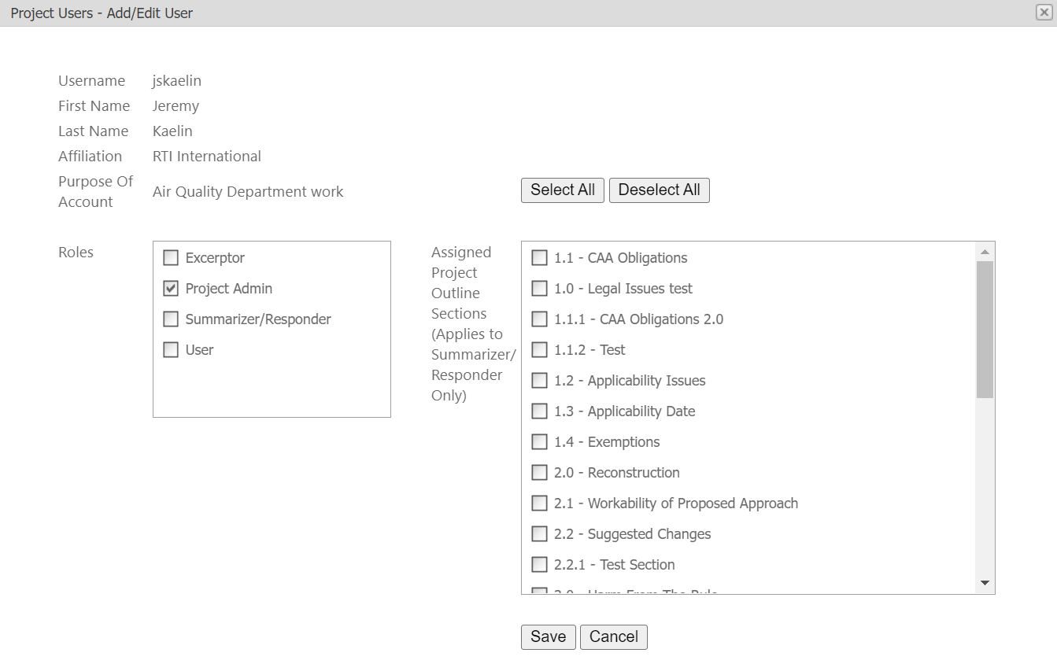

Project Administrators can grant users 4 different levels of access to the project: User (read-only access), Excerptor (access to comment letters and excerpts but no ability to edit Summaries/Responses), Summarizer/Responder, and Project Admin. Select whichever role you would like to assign a specific user to via the Roles menu.

If a Project Administrator assigns a user to a Summarizer/Responder role, the Project Administrator must also select from the menu to the right hand side the Outline sections that user will have the ability to write and edit Summaries in. The Project Administrator can use the ‘Select All’ button above this menu to grant a user access to all outline sections.

# Unlock Summaries Tab [only for administrative role]

Occasionally, a user will be working within a Summary window and close the window in an improper way (i.e. the browser crashes, the user manually quits the window not using the RTI CHARM tool prompts and functionality). When this happens, this can cause Summaries to be erroneously ‘locked’. As a way to ensure that multiple users will not be editing the same text at the same time, the RTI CHARM tool locks Summaries once a user as elected to edit one, so that only that user can make changes to the active Summary. However, when Summaries are exited not via the Save or Cancel buttons within the RTI CHARM tool, these Summaries can remain perpetually locked.

In order to unlock these summaries, Project Administrators can go to the Unlock Summaries tab. If a summary is locked, it will appear in the list, like the example below:

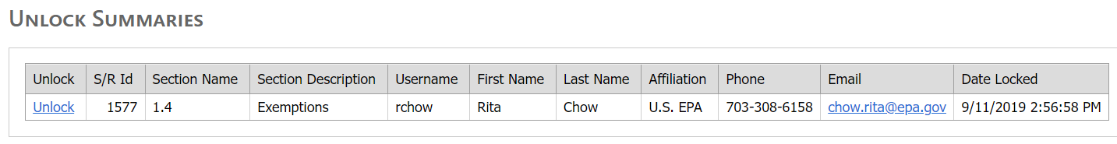

To unlock the Summary, the Project Administrator simply needs to click ‘Unlock’ beside the applicable Summary.

It is good practice, as a Project Administrator, to ensure that a Summary is truly erroneously locked (i.e. no users are currently editing the Summary), else that person’s work will not be saved once the Summary is unlocked.

# Comments Imports Tab [only for administrative role]

In this tab, the Project Administrator will be able to confirm the status of a batch comment import using the Comments Import Template.

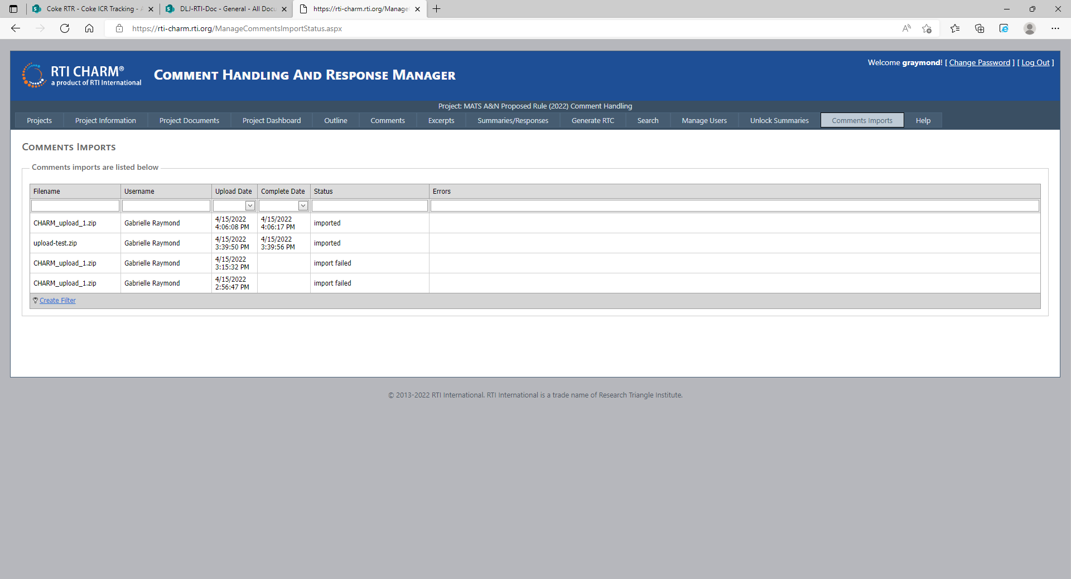

# Help Tab

In this tab, the user guide and quick start guides are available.

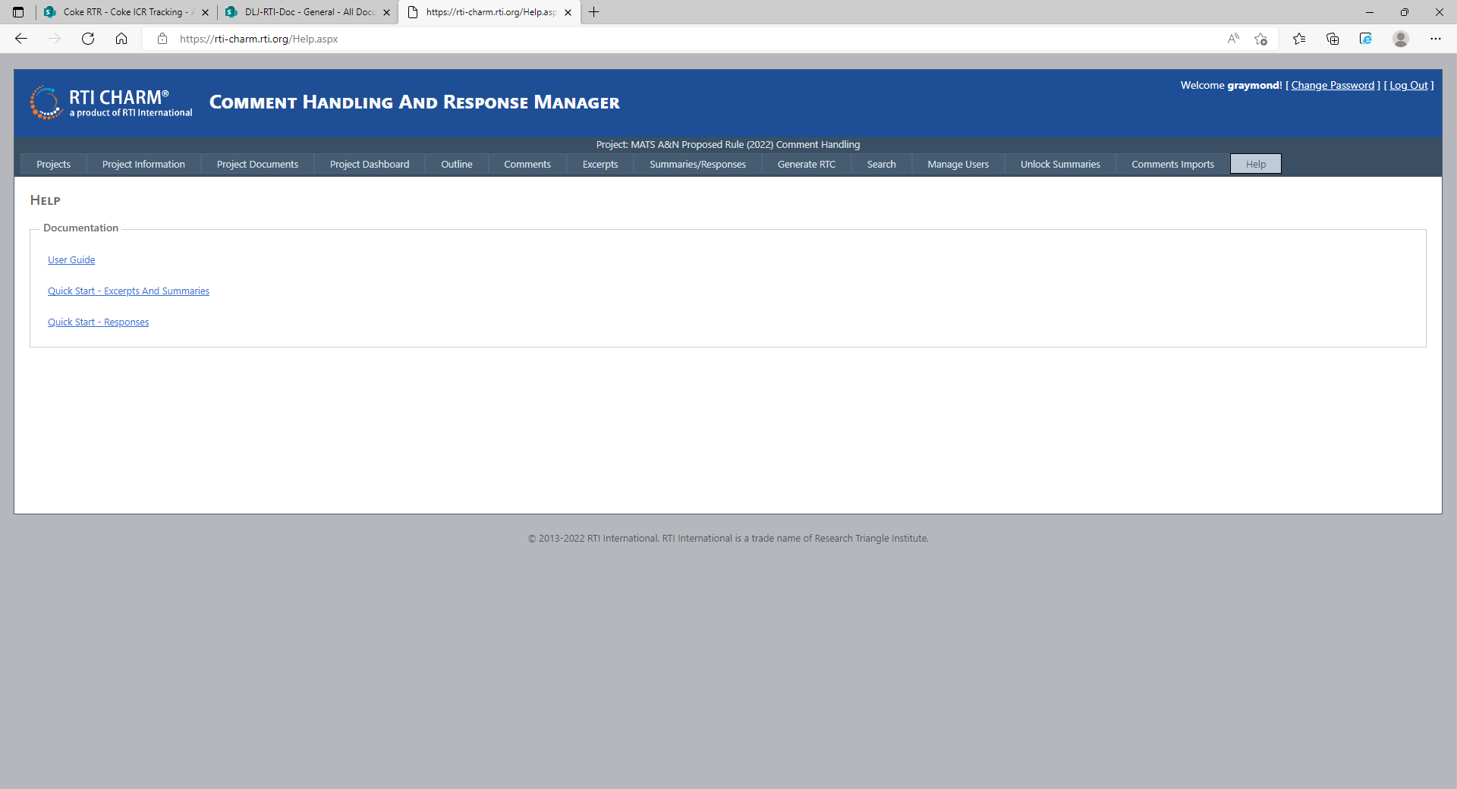

1. After selecting an excerpt, you may enter a response without a summary if you are preparing an excerpt-response RTC document. [↑](#footnote-ref-1)