**RTI Comment Handling and Response Manager (RTI CHARM®)**

**Quick Start Notes for Responders**

September 2022

RTI CHARM Tool Internet Address:

<https://rti-charm.rti.org/Account/Login.aspx>

Registering for an RTI CHARM Tool Account:

You will need to register for an account before you can log into the RTI CHARM tool.

Navigate to the RTI CHARM Tool Internet address above, click “Register,” and supply your registration information. You will be notified via email when the username and password you supply are activated.

Logging In:

If you have not registered with the RTI CHARM tool before, register using the “register” button on the login page. For both new and existing users, email the RTI CHARM tool coordinator and request access to the specific project. After you have been notified of approval to access the RTI CHARM tool, and to the specific project, use your registered username and password to log in at the internet address above.

Upon log in you will be asked to select the project you are working on.

Note that access is granted on a project-specific basis. When you log in, you will see, and have access to, only those projects for which you have been granted access.

RTI CHARM Tool Coordinator:

Please contact the RTI CHARM tool coordinator with questions regarding use of the RTI CHARM tool.

Lisa Scruggs

(919) 316-3745

[lkscruggs@rti.org](mailto:lkscruggs@rti.org)

Draft Responses:

Select the outline section you wish to draft responses for in the Summaries/Responses tab. The summaries/responses for that section will appear in the table to the right of the

Summaries/Responses tab. You can enter a keyword into the search bar above the outline sections to navigate to a specific section faster.

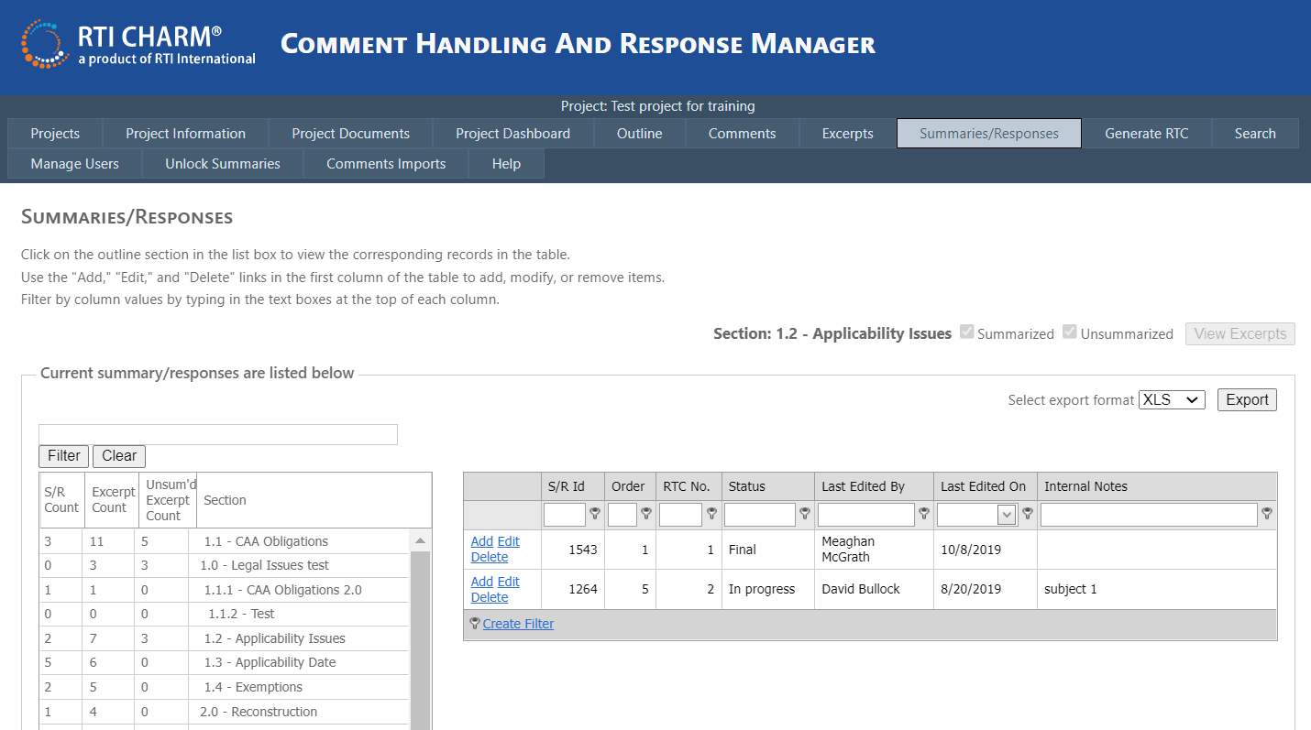

Choose a summary/response and select “Edit.” Note: If your only choice is “View” you need to request permission to edit content in the outline section selected.

Enter your response in the response text box of the Manager Summary/Response window.

Status is useful for tracking progress

Sort order determines placement within the RTC section.

Summary/Responses can be moved to another section using this pull-down list.

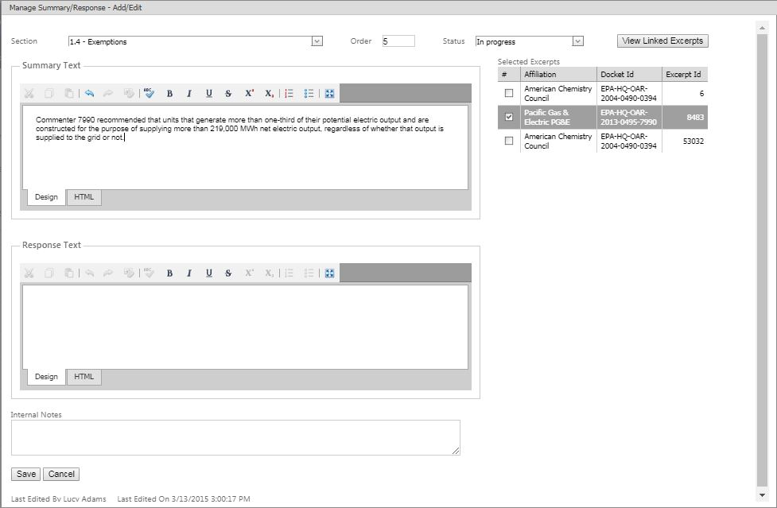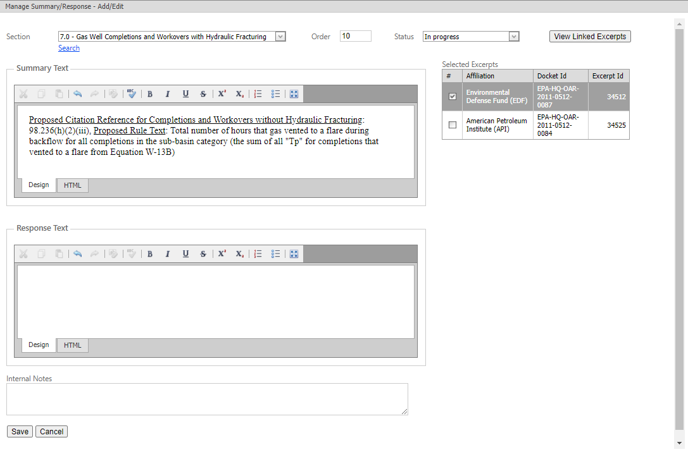

Use the Search feature to search for key words in a summary to see where it might best be placed

Internal notes are useful for characterizing summary topics, or providing notes to the team.

Excerpts are linked to summaries and responses

The last person to edit a summary or response is noted. The name/date stamp does not change upon viewing; only when edits are made.

 Note: the full screen button in the response box is useful if you need to expand the text box window to see more of the text you are editing.

You may work directly in the response text box or choose to prepare responses in Word and paste them into the box. If you prepare responses in Word, please use Times New Roman 12 point font because your font selection will translate directly into the RTC document.

If pasting in text into any text box within the RTI CHARM tool from an outside source, it is generally good practice to highlight the new text once inserted into the RTI CHARM tool text box and click the format eraser tool (). This way, any extraneous formatting that is not compatible with the RTI CHARM tool text boxes will be erased.

Generate Response to Comments (RTC) Document Sections:

Use the Generate RTC tab to generate a Word document of the sections of the response to comments (RTC) document that you wish to review. Click the sections you are interested in, and then click the Generate RTC button.

The default RTC document generation format is to provide comment summaries and responses, which is easiest to review. For additional content,

* Checking the Excerpt Bibliography button will add, above the summary, the commenter name, affiliation, and comment letter page numbers that went into each summary.
* Checking the Excerpts button adds all of the comment excerpts used to develop each summary, placed above the summary.

