**RTI Comment Handling and Response Manager (RTI CHARM®)**

**Quick Start Notes for Excerpt and Summary Team**

September 2022

# RTI CHARM Tool Internet Address:

<https://rti-charm.rti.org/Account/Login.aspx>

# Registering for an RTI CHARM Tool Account:

You will need to register for an account before you can log into the RTI CHARM tool.

Navigate to the RTI CHARM Tool Internet address above, click “Register,” and supply your registration information. You will be notified via email when the username and password you supply have been activated.

# Logging In:

After you have been notified of approval to access the RTI CHARM tool, use your registered username and password to log in at the internet address above.

Upon log in, you will be asked to select the project you are working on.

Note that access is granted on a project-specific basis. When you log in, you will see, and have access to, only those projects for which you have been granted access.

# RTI CHARM Coordinator:

Please contact the RTI CHARM tool coordinator with questions regarding use of RTI CHARM tool.

Lisa Scruggs

(919) 316-3745

[lkscruggs@rti.org](mailto:lkscruggs@rti.org)

# Work Assignments

Comment letters are assigned to excerpters in the Comments tab, under the column labeled Excerpt Lead.

Document sections are assigned to summarizers in the Outline tab, under the column labeled Summary Lead. Summarizers are given summary access on a section-by-section basis. Contact an Administrator if you need access to a section.

# How to Create an Excerpt

Every excerpt is linked to its comment letter source. In the Comments tab, click the Excerpt link for your assigned comment letter.

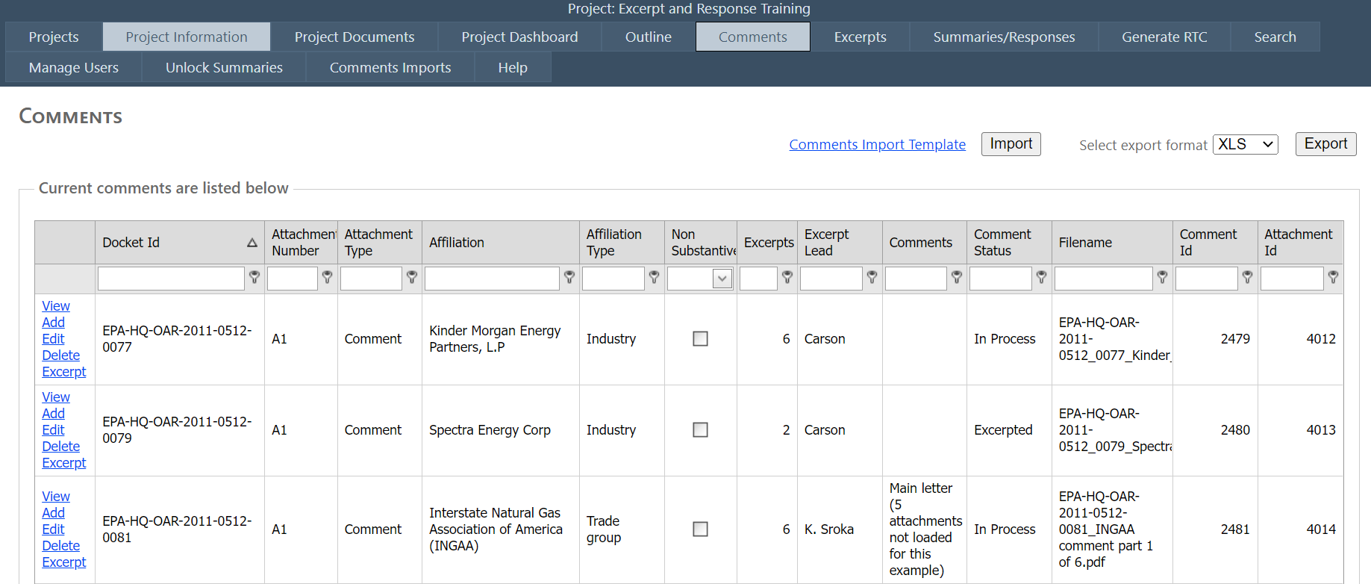

You will link to the excerpt table for that comment letter. To begin creating excerpts for a specific comment, click on the “Add Comment Excerpt” link. As excerpts are created a list of the excerpts for a specific comment will appear. Click on any of the Add links to continue to create new excerpts. If you would like to view the current excerpts from a comment letter, click the “View Excerpts” button at the top right to generate a word document that includes either the summarized, unsummarized, or both types of excerpts depending on the check boxes selected. You also have the option to include the internal notes from each excerpt in the export file that is generated.

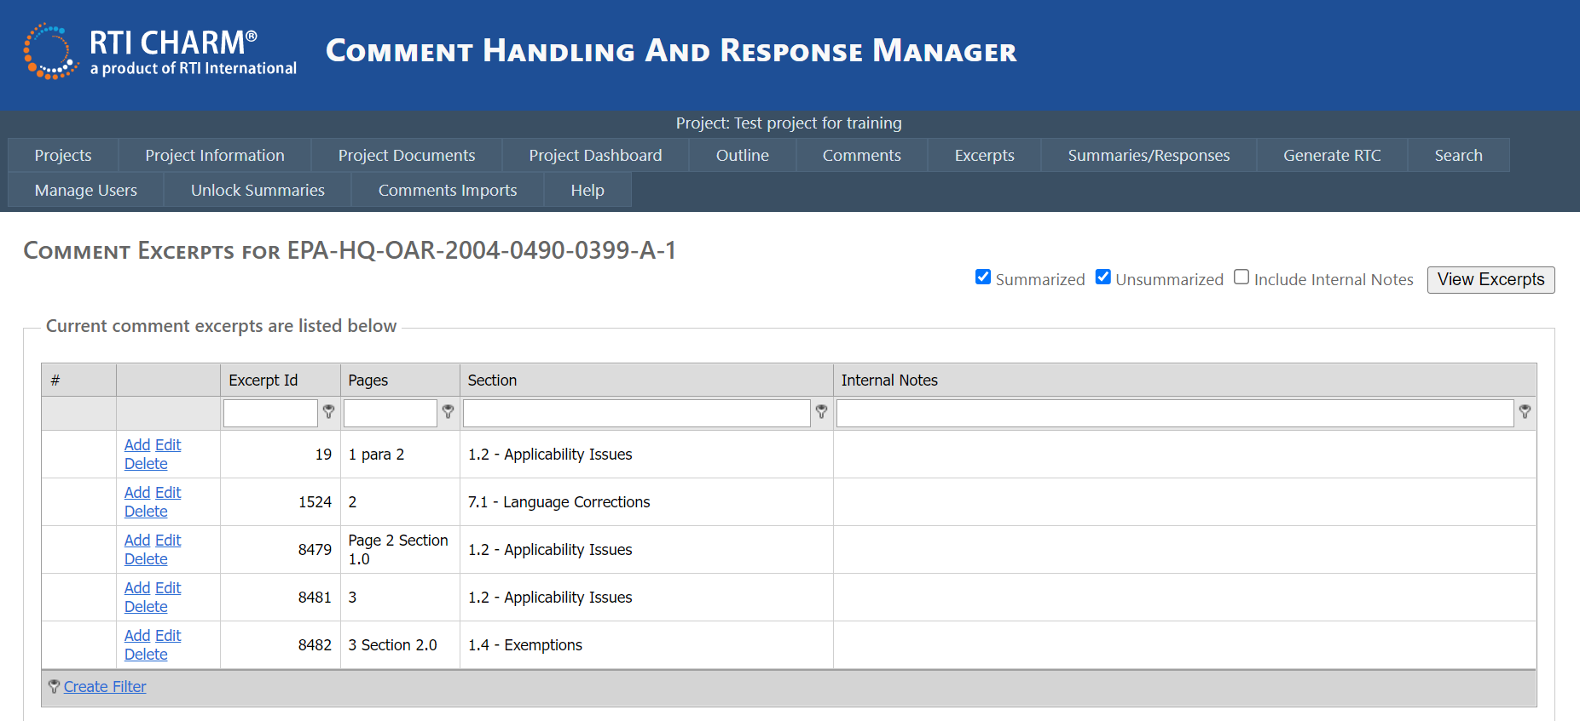

Once the user opts to add a new excerpt, a window will appear (see below) over this page where the user will insert the excerpted text and other identifying information around the excerpt.

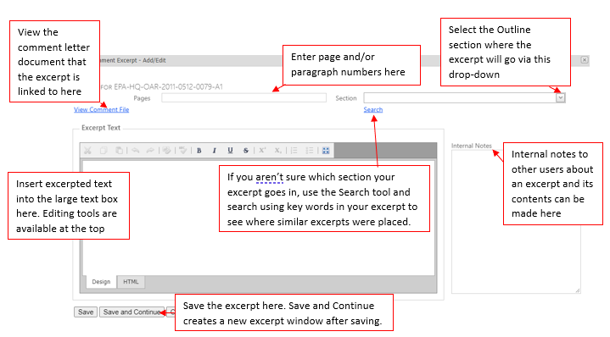

At the bottom of the Excerpt form are buttons to Save, Save and Continue, or Cancel.

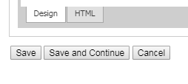

The Save button will save the text to a unique Excerpt ID and close the window. The Save and Continue button will save the text to a unique Excerpt ID and refresh the excerpting window so that the user can create a new excerpt without leaving the excerpting environment. The Cancel button will close the excerpting window. Prior to closing the window, the user will see another pop-up after clicking Cancel which will ask if the user is sure that they would like to leave the current page. Any information in the excerpting window after the user elects to Cancel or close the excerpting window will not be saved.

Once you have completely excerpted a comment letter, go back to the Comments tab, click Edit to edit the comment letter row. Set the comment's status as Excerpted in the applicable dropdown box.

If you navigate to the Excerpts tab, you will see a list of the outline sections per project. Click on an outline section to view the excerpts that were assigned to that outline section. You can enter a keyword into the search bar above the outline sections to navigate to a specific section faster.

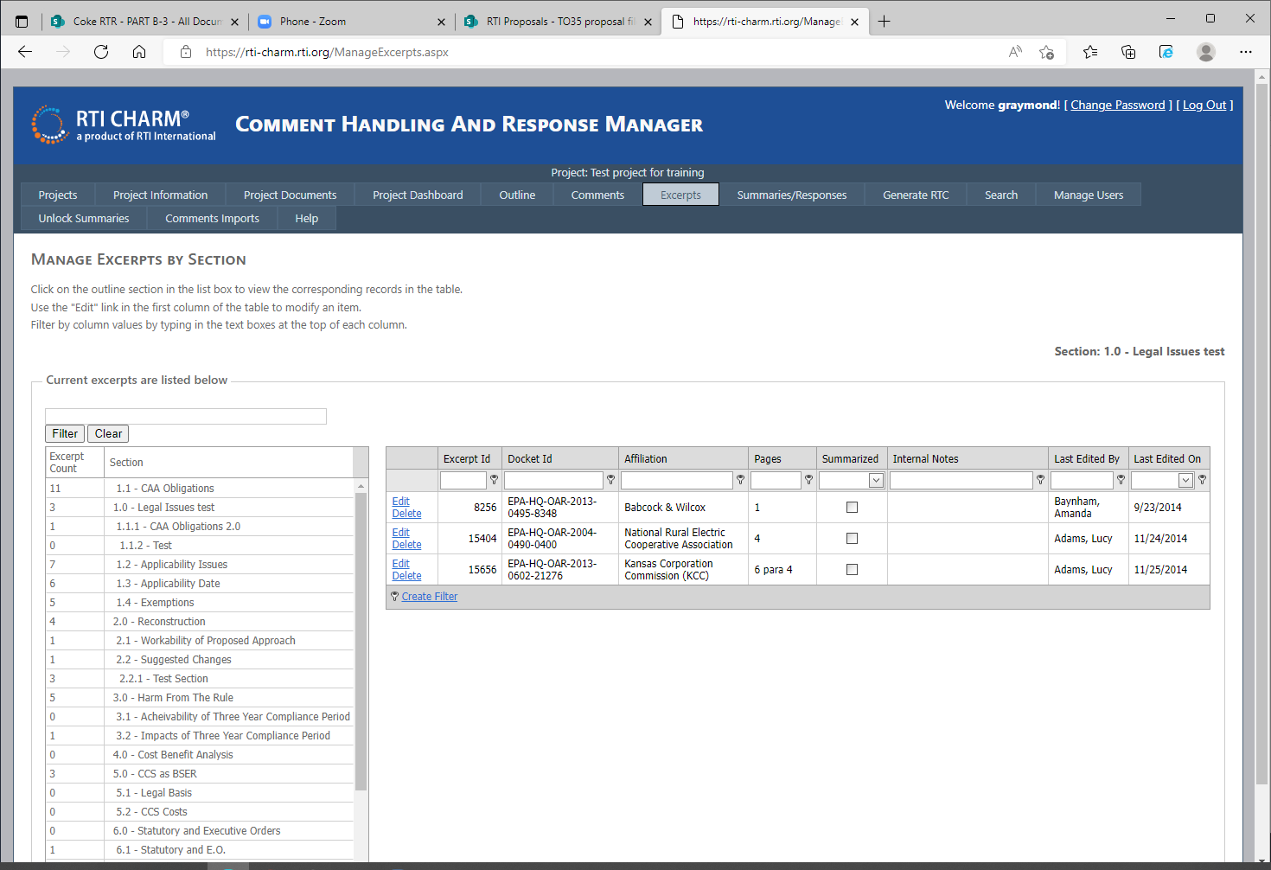

# How to Create a Summary

Summaries and responses are accessed through the Summaries/Responses tab. Select your assigned outline section. Any summaries that have already been prepared will appear in the table. You can enter a keyword into the search bar above the outline sections to navigate to a specific section faster.

Use the View Excerpts button to create a Word document with either all of the excerpts (summarized and unsummarized), just the summarized excerpts, or only the unsummarized excerpts.

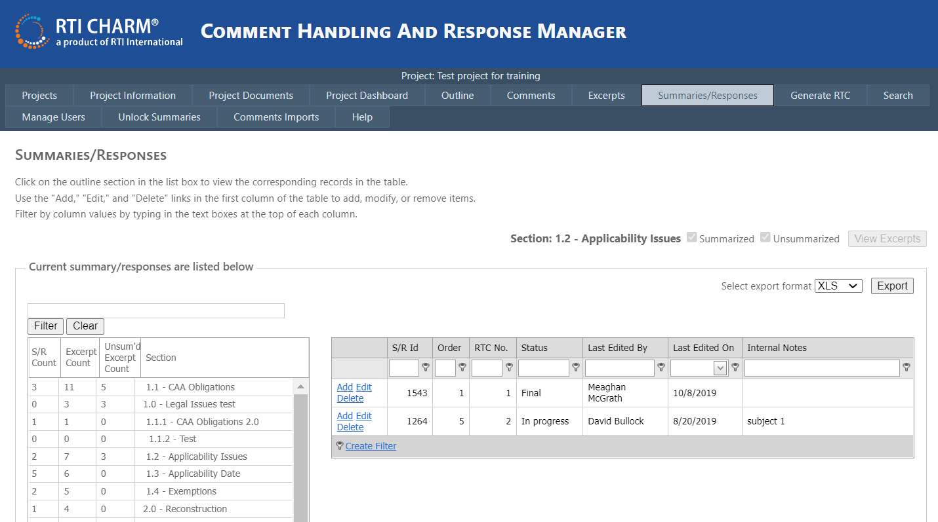

In the Word document, an excerpt will look like this:

4.3.1 CCS as an Adequately Demonstrated Technology

Howard Feldman; AFPM & API; EPA-HQ-OAR-2013-0495-10098; 2284; 4 para 2

-- in regard to the unsuitability of CCS for coal units:

Capture of CO2 from natural gas streams is a fundamentally different process than capture of CO2 from combustion stacks

Each excerpt is labeled with the commenter's docket ID, marked in red for this illustration, an excerpt ID, marked here in blue, and the page and paragraph in green, at the end of the excerpt title. The excerpt ID is unique for each excerpt.

Before summaries are developed, summarizers should use this Word document to review the excerpts in their section. The summarizer may wish to move some excerpts to other subsections in their section or to another section. It is easiest to move excerpts before developing summaries. Excerpts are listed by section under the Excerpts tab and are identified by their unique excerpt ID. Move an excerpt by selecting the correct section from the pull-down list on the excerpt form. Write in the excerpt text box if the excerpt has been moved, and what section it came from. Discuss placement with other section leads if it is hard to find a good place for an excerpt.

To add a new summary to a section with no previous summaries made, click on the “Add Summary/Response” link. To continue adding summaries, use the Add or Edit links to create a new summary or edit an existing one, respectively. The Delete link should be used with caution – because the RTI CHARM tool is a database, a deleted record cannot be retrieved.

The summary entry form, accessed using the Add or Edit links, looks like this:

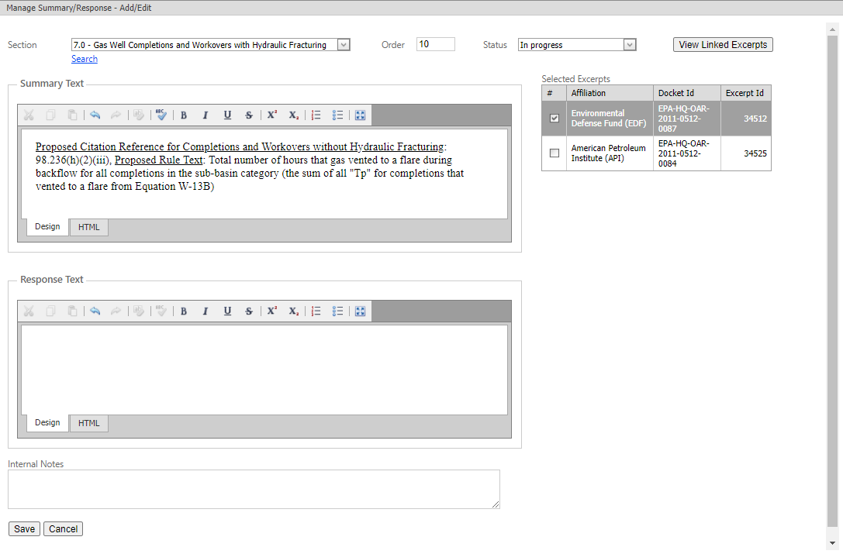

The “View Linked Excerpts” button in the top right corner of the entry form creates a word document, external to the entry form, which contains the excerpts which have already been linked to a particular summary (indicated by a check and a dark gray background in the Selected Excerpts table).

Below the Response Text header and text box is a third text box labeled ‘Internal Notes’ (see screenshot below). Users can input any text here which may be applicable to the summary and can help any user accessing this summary understand any subtle nuances of the content therein. Typically, users will put a sentence characterizing the summary in this box so that the content of the summary is clear and visible to any user from the main Summary/Responses page.

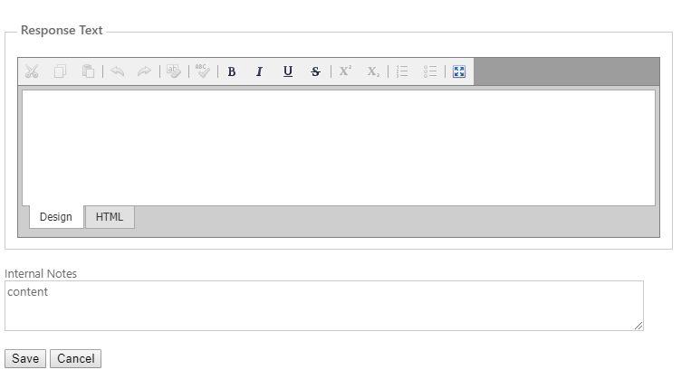

After checking the excerpts you wish to link to each summary, prepare the summary using the excerpts Word document. Typically, summary writers will prepare the summary text in a word processor and copy that text into the RTI CHARM tool text box.

* Each summary must have at least one excerpt selected to link that excerpt with the summary. Once an excerpt is selected for one summary, it will not appear on the list for other summaries.
* Note that in the comment summary, the commenters are identified by their docket ID. Please take care to use the docket ID (not the excerpt ID) in the summary text.
* Enter the summary order leaving space for additional summaries to be added later (e.g., order summaries using 5, 10, 15 instead of 1, 2, 3).
* The section pull down allows you to reassign a summary/response and selected excerpts to a new outline section.
* If you believe a summary is in the wrong section, or that their might be another similar summary that can be combined with yours, you can use the Search feature located below the section pull down to search for key words in your summary. The Search tool will then provide you with a list of summaries and excerpts that also contain those key words, so you can either move your summary/excerpts to another section or move other summaries/excerpts into your section.
* The internal notes field is useful for labeling each summary.
* There is a Save button at the bottom of the summary/response form. The RTI CHARM tool does not save automatically.

Summary/Response table with labeled summaries:

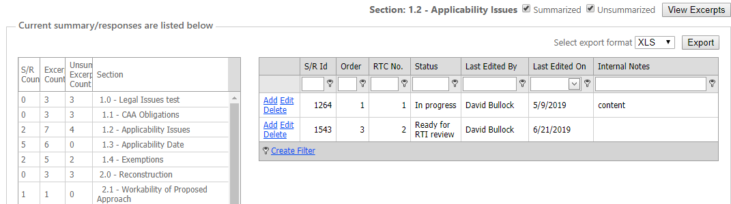

# Excerpt Content

## What is in an Excerpt?

Comment letters, including attachments must be reviewed. Any significant information should be excerpted. Many attachments support the commenter's argument but are not specific to the proposed rule. Note these attachments in the excerpt text as references, but they do not need to be excerpted. However, if they include data pertinent to the rule, they should be noted as a New Data excerpt. Include significant footnotes – as part of an excerpt, or as an individual excerpt.

### What to Include

Include footnotes, references and citations in your excerpt. When references and citations are included in the text box tag them with a header: "Commenter Reference".

If the commenter refers to preamble sections or FR page numbers, please include that in the text.

Note attachments when referenced in the comment text.

If a commenter has provided data, such as emissions, costs, or control data, create an excerpt describing the data, where it can be found in the comment letter, and assign the excerpt to the New Data section of the outline.

Proposed rules that involve risk and technology review (RTR) may have commenters submitting data for additional emissions modeling. In that case, create an excerpt in the outline section for data submissions for the emission model, identifying the commenter and describing the data.

Example of footnotes and citations:

According to Cabinet analysis, the levelized cost of electricity (LCOE) with CCS technology is higher than the LCOE without CCS technology.15 Cabinet estimates indicate that the addition of CCS to either an IGCC or USCPC facility would increase cost per kWh by 40 percent to 58 percent respectively.16

<footnote 16 refers to summary cost projections, Appendix A includes plant cost data>

Commenter Reference:

15 http://eec.ky.gov/Documents/GHG_Policy_Gina_McCarthy_letter.pdf

16 See page 90 of Appendix A of this submission, State of Kentucky Electric Generating Report, Final, Cynthia Schafer, January 8, 2014.

Include commenter's Incorporation by Reference statements. There may be a separate outline section for these statements.

## How Much Information Goes in an Excerpt?

Excerpts need to be broken into small subtopics. Consider how a summarizer will group some excerpts about one subtopic into one summary and other excerpts for a related subtopic into another summary. Many excerpts can be grouped into a summary, but an excerpt can be linked to only one summary.

Because you are breaking comments into bite-sized pieces, you may need to provide some context. Put yourself in the place of a summarizer as you decide about adding context. If you need to add context, include the text before and after an excerpt within carets (greater than/less than symbols), or put notes to the summarizer in the text block.

An example of context is shown in the < > carets below:

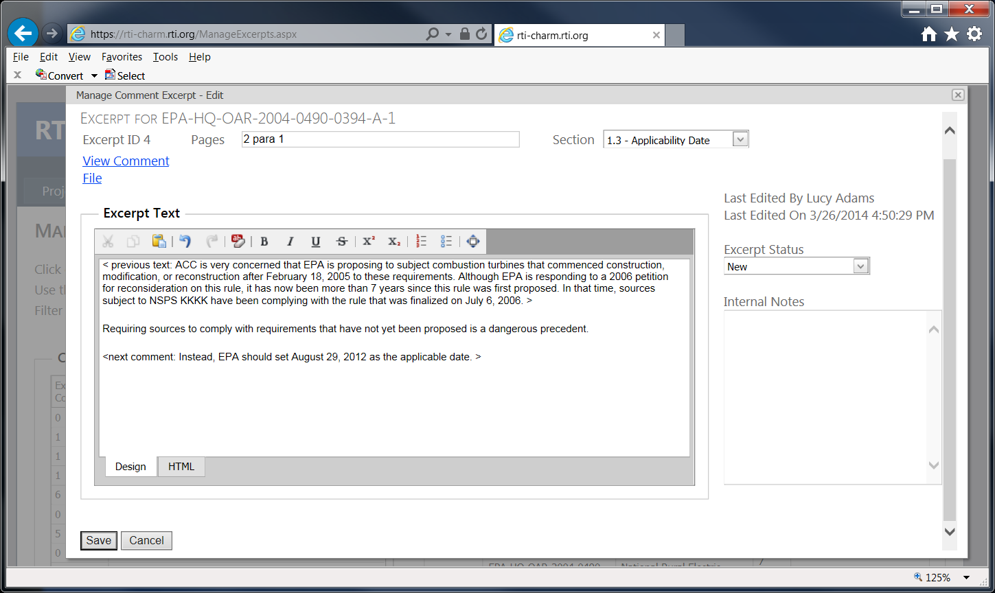

Styles for Excerpts

* Not all of the comment letter text needs to be excerpted. Include text that is relevant to the proposed rule, or addresses legal, policy or technical issues.
* A comment letter may include a cover letter and attachments. Not all need to be excerpted. If, after a review, you decide that a cover letter or attachment does not need to be excerpted, mark it as finished in the comment tracking table (under status). Examples of content that do not need to be excerpted: general statements for or against the rule in a comment letter that has other more substantial comments; descriptions of the commenter’s business operations (how many employees, etc.); reiterations of materials in the docket or preamble; journal articles and reports not prepared as a response to the rule (note that they are cited).
* It is unlikely that a comment letter in the RTI CHARM tool will have an excerpt that goes in General Support/General Opposition. These sections are generally intended for mass-mail campaigns and non-substantive letters from individuals. We generally enter only substantive letters into the system. Excerpt the points in the letter that have some bearing on the rule.
* Sections for new data or data submissions should have excerpts that describe the form and content of the data and serve as a flag for the summarizer to collect the data from the comment letter. These sections are for data that have either been explicitly requested or that have been submitted to correct issues in the rule.
* Keep excerpts limited to a single topic. Consider how the client will have to respond. Provide context before and after, if needed.
* Include citations and listings of references under the heading “Commenter’s Reference” in the excerpt text.
* Tables and charts will not print out from the RTI CHARM tool. Reference these items in your excerpt, provide a description – often, the title and chart labels will do.
* If a comment letter is saved as an image (i.e., not searchable text) or is password protected, you may not be able to cut and paste text from that pdf. If you have Adobe with text recognition, use that to convert image pdfs to searchable pdfs. If a pdf is password protected, print to another Adobe file, then use text recognition.

**Other small things:**

* Put everything you want the summarizer to see in the text box.
* Clean up text as you work. An unrecognizable symbol in the excerpt text will slow down the summarizer’s work and could distort the text’s meaning. Inconsistent text in multiple formats is distracting.

# Styles and Formatting for Summaries

Styles for summaries are highly project specific and driven by client preferences. Summaries can be high level with few details, or can be compilations of excerpts, retaining all the details. Formatting preferences are also highly project and client specific. It is good practice to discuss and agree on style and formatting conventions in advance of summary development.

In the absence of client-specific instructions, the following guidance may be used.

**General**

* Summarize the meaning of the comment, but do not over-simplify. Cut and paste text if that works best.
* Language should be neutral. Remove any emotional or attacking language. Some suggested words include: stated, agreed, confirmed, observed, and disagreed.
* Use the past tense for summaries.
* When applicable, refer to EPA as “the EPA” or “the Agency.”
* One (1) space follows a period or other punctuation mark (not 2 spaces).
* Do not indent paragraphs.
* Typestyle: Times New Roman, 12 point, black *or* use the RTI CHARM tool text box format eraser

**Specific Instructions**

* Commenters should be referred to by their 5- or 6-digit numbers. For example, EPA-HQ-OAR-2013-0602-16826 = 16826.
* When a comment is unique (i.e., only one commenter raised the issue), the comment should not include parentheses. For example,
  + *Commenter 16826 agreed with the EPA’s effort to reduce mercury emissions from power plants.*
* When multiple commenters address the same item, commenter identification numbers are to be included parenthetically when describing the comment. The parenthetical reference should be ordered from smallest to largest identification number. For example,
  + *Several commenters (16121, 16826) agreed with the Agency’s effort to reduce mercury emissions from power plants.*
* If you have multiple points or thoughts in a single summary, order them in individual paragraphs.
* Notes to EPA should be embedded in the comment summary by using [brackets].
* Refer to tables, figures and graphics by briefly describing the content of the table, figure or graphic, citing its number in the document and the docket ID (i.e., Table 6-3 of comment 16121).
* Refer to attachments and reports in the text and include the docket number. For example: *Commenter **** provided a journal article describing their new control process, the article is an appendix to the docket entry EPA-HQ-OAR-2013-0602-*****.*
* Include information in footnotes in the comment summary, if it is relevant. If the footnote is a citation, note that in the summary text, if it is relevant.
* Endnotes and references cited in the comment text can be noted in the summary text: *Commenter **** provided several references supporting this point.*

Or, for more detailed listings, at the bottom of excerpts and summaries:

*Commenter References:*

12 EPRI, Summary of Technology Report, May 12, 2014.

13National Research Council. Review of Test Data for ..... June 2012.

Some summary projects will require additional formatting for summary text:

* Create a "thesis" sentence at the beginning of each summary.
* Use thesis sentence or another brief description in the notes field to identify each summary.
* Use the notes field to track excerpt ids, RTC section comment number, excerpts from priority commenters, and other tracking and organizational information.